Relaxed Performance Information Pack for
The Smeds and The Smoos
Wednesday 15 December, 1.30pm
Tuesday 28 December, 10.30am
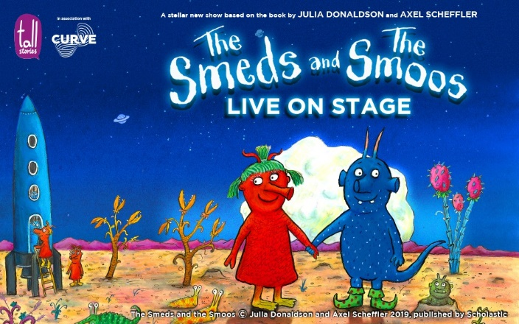
Box Office Telephone: 0116 242 3595
Box Office Email: tickets@curvetheatre.co.uk
Address: Curve, 60 Rutland Street, Leicester, LE1 1SB

Contents
Hello and What is a Relaxed Performance?.........................................................2
Important Information for Your Visit……………………………………………………….….3 - 4
Getting to Curve…………………………………………………………………………………………..4 - 5
About the Show and Things to Look Out For……………………………………………….6 - 7
The Cast…………………………………………………..…………………………………………………..8 - 9
The Smeds and The Smoos: The Story……………………………………………………..10 - 12
Visual Story: Your Visit to Curve..…………………………………………………………….13 - 21
Production Gallery………………………………………………………………………………………….21
Hello!
We are looking forward to welcoming you to Curve for our Relaxed Performance of The Smeds and The Smoos. We hope you are excited to see the show!
This pack is designed to give you a bit more information about the performance and our theatre ahead of your visit.
What is a Relaxed Performance?
Relaxed Performances are open to everyone but are especially tailored to support audiences with additional needs who may benefit from a more relaxed performance environment. This may include children, young people and adults with neurodivergence, such as autism, learning difficulties and other sensory or communication needs.
Throughout the performance the lights will remain on, and whilst the Studio doors will be closed, audience members will be free to come and go from the Studio if they need a break from the performance. There is also a relaxed attitude to noise during the show, and the sound and lighting will be adapted to more comfortable levels.
Widgit Symbols © Widgit Software 2002-2021, www.widgit.com.
Important Information for Your Visit
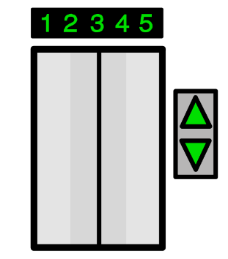
Customers are advised our public lifts at Curve are currently unavailable due to essential maintenance. Please be assured we are working with our suppliers to complete this programme of work as quickly as possible.
If you have any concerns about this in relation to your visit, please get in touch at 0116 242 3595 or e-mail tickets@curvetheatre.co.uk, where a member of our team will be happy to assist you.

Following the latest Government updates, wearing a face covering at Curve is now mandatory for all audiences and visitors over the age of 11 years. This will apply to everyone inside the building and during every performance (except when eating or drinking). In line with the Department for Education guidelines, all school groups (Key Stage 3 and above) will also be required to wear a face covering.
We understand some people will be exempt from wearing a face covering and we ask anyone this affects to inform our Visitor Experience team members upon arrival. We also ask that you consider wearing a face shield or visor.
In addition to face coverings, we continue to have in place a number of Covid-safety measures throughout the building to ensure everyone visiting and working at Curve is as safe as possible, including increased ventilation and enhanced cleaning.
Widgit Symbols © Widgit Software 2002-2021, www.widgit.com.
Whilst it is not a requirement for entry to our building and we will not ask for proof, we encourage all audience members to take a Lateral Flow Test ahead of visiting us.
All Covid-safety measures are regularly reviewed in line with Government guidelines, please visit our website at www.curveonline.co.uk/plan-your-visit/faqs/ for further details.
Getting to Curve
Our address is Curve, 60 Rutland Street, Leicester, LE1 1SB.
Here is a map of where Curve is in the Cultural Quarter, and the surrounding area.
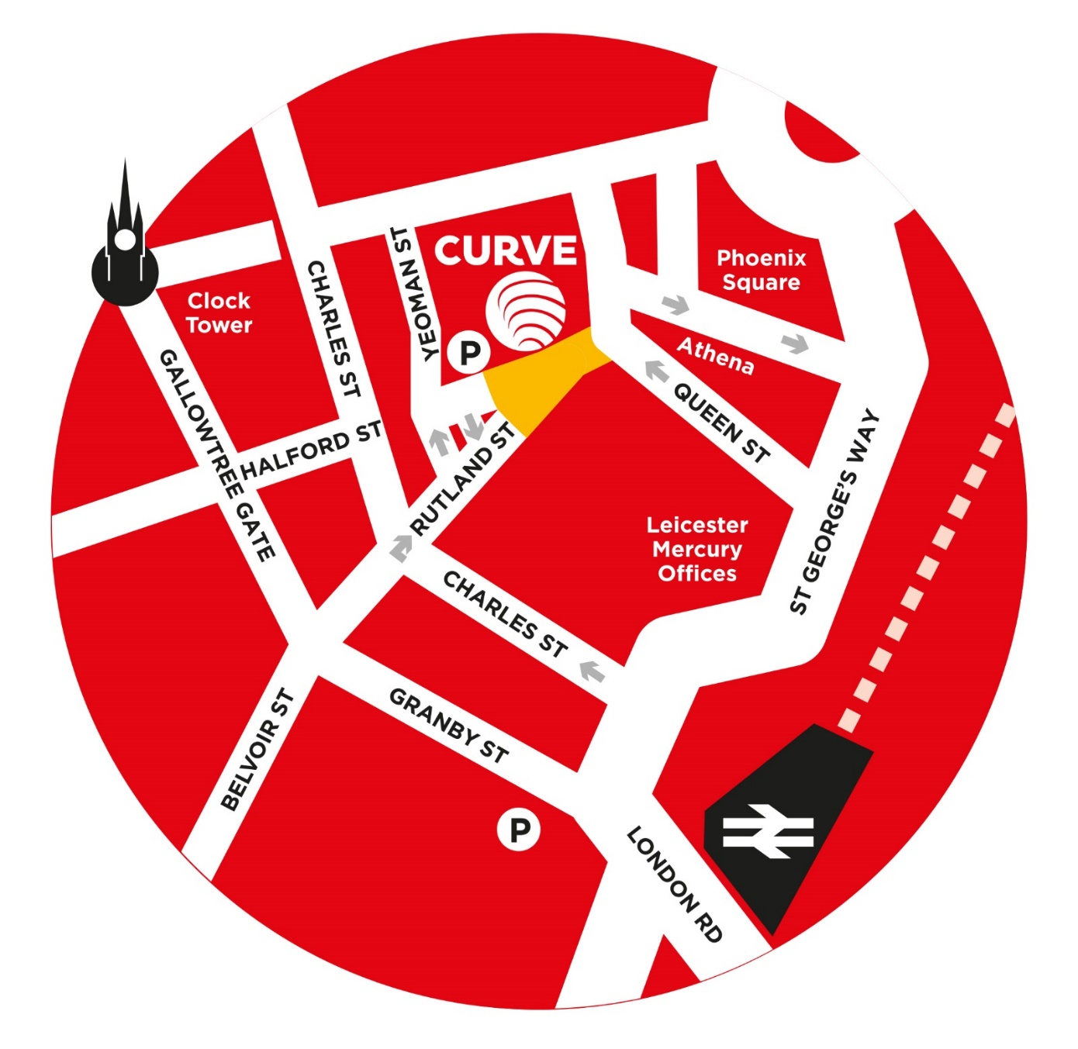

Widgit Symbols © Widgit Software 2002-2021, www.widgit.com.
Getting here by Car
The nearest car park to Curve is the NCP Rutland Centre Multi-storey Car Park, next door to the theatre. The address for the car park is 56 Halford Street, Leicester, LE1 1TQ, and it has seven access spaces.
Visitors to Curve can park at NCP Rutland Centre Multi-storey Car Park for a reduced rate of £5.50 – please validate your car park ticket at our Box Office during your visit.
Other nearby car parks include Queen Street Car Park (LE1 1QD), NCP Lee Circle (LE1 3RE, four access spaces) and Highcross John Lewis Car Park (LE1 4QJ, 70 access spaces).
There is also a drop-off point outside our theatre.

Getting here by Bus
All Leicestershire bus services have stops within a three to 10-minute walk of Curve. Services that stop on or near Humberstone Gate or at Haymarket Bus Station are the closest.
Due to the temporary closure of St Margaret’s Bus Station, regional bus services are currently terminating at alternative stops around the city. For more information, please see www.leicester.gov.uk/media/5k3bqvgd/smbs-replacement-stops-map.pdf, or contact service providers directly for the latest information on your service.
For more information on your nearest bus stop, visit the Leicester City Council website at www.leicester.gov.uk/transport-and-streets/travelling-by-bus/, or call Traveline on 0871 200 2233.
Getting here by Train
Leicester Train Station is less than a 10-minute walk away via Charles Street. For the latest service information, please visit www.nationalrail.co.uk.

About the Show
The Smeds and The Smoos is based on the book of the same name by Julia Donaldson and Axel Scheffler. You might have read this at home!
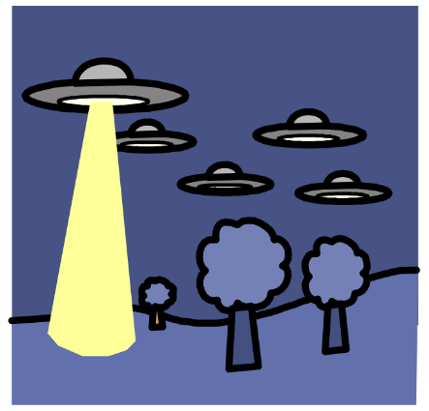
If you are new to the book, it tells the story of two families of aliens called Smeds and Smoos who live in a far-off planet and cannot be friends. So, when young Smed Janet and young Smoo Bill fall in love and zoom off into space together, their families follow them on an adventure to bring them home. If you would like to find out more about the story before your visit, please see pages 10 – 12.
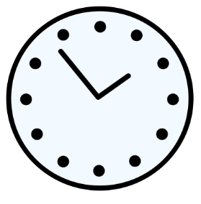
The running time for The Smeds and The Smoos is 55 minutes with no interval.
The performance is recommended for children aged 3+ and their grown-ups.
Things to Look Out For
The actors in The Smeds and The Smoos use different costumes and puppets to play the different aliens in the story, as well as making lots of different alien noises!

Widgit Symbols © Widgit Software 2002-2021, www.widgit.com.
The show can be quite loud in places, with different sound effects, music and songs throughout. However, the volume will be reduced during the relaxed performance.

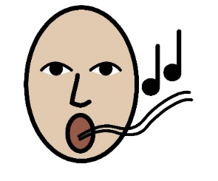
You are welcome to sing along and join in with the songs if you would like to – other audience members may also be quite loud during these parts!

There are other moments during the show when the actors will talk directly to the audience, or ask questions like “Has anyone seen Janet?” You can reply or not, it’s up to you - no one will be made to feel embarrassed.
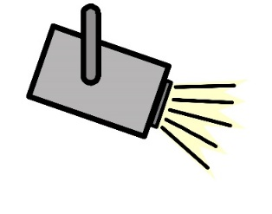
Throughout the performance we will keep the main lights on in the auditorium but there will be different lighting changes during the show, and especially during songs.

Spoiler Alert!
When the families are visiting Lurglestrop, The Lurgles ask Grandfather Smed and Grandmother Smoo to water the roses on the planet – including the roses in the audience! At this moment, Grandfather Smed and Grandmother Smoo will user a plant mister and a water pistol to spray water over the audience. It will only be a few light drops and will only last a few seconds, but the audience may shout and whoop as the water lands on them.

Widgit Symbols © Widgit Software 2002-2021, www.widgit.com
The Cast
There are four actors in the show, two male and two female.
All of the actors act, sing and dance during the show, and help to tell the story as narrators as well as playing their characters.

Dan Armstrong
Bill

This is Dan.
He is an actor.
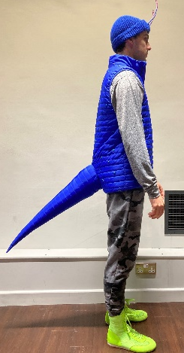  Dan plays the blue Smoo Bill in the show. | 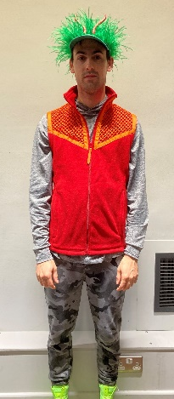  Dan also plays Jeffrey, a red Smed who helps find Janet and Bill.
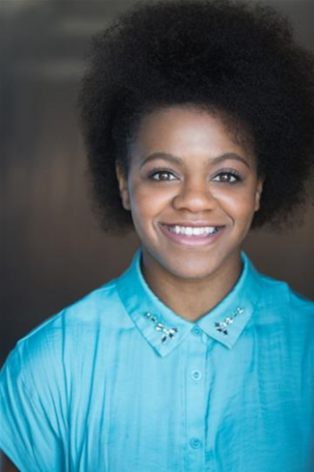  Althea Burey  Janet  This is Althea.  She is an actor. | Continue meeting the cast
Althea plays the red Smed Janet in the show. | 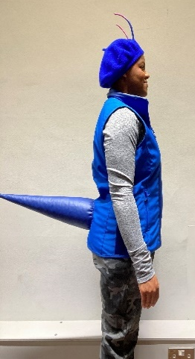  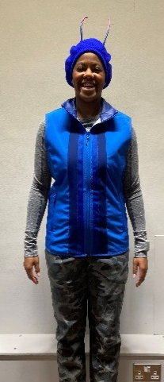  Althea also plays Betty, a blue Smoo who helps find Janet and Bill.
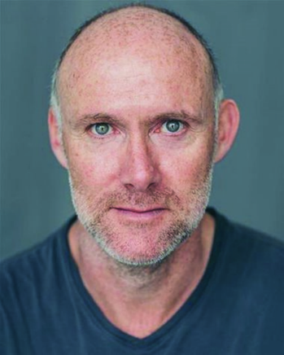  Tim Hibberd  Grandfather Smed  This is Tim.  He is an actor. | 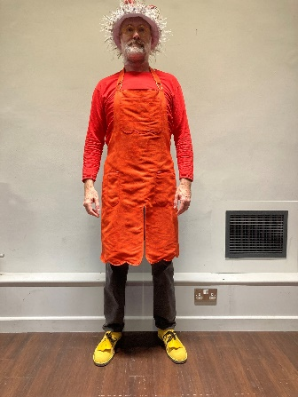  Tim plays Janet’s Grandfather in the show.
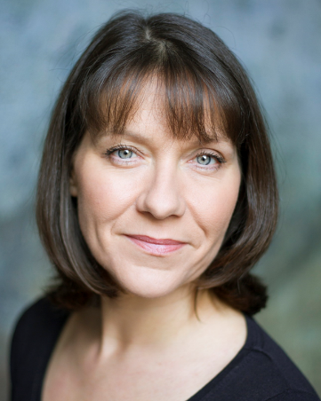  Angela Laverick  Grandmother Smoo  This is Angela.  She is an actor. | 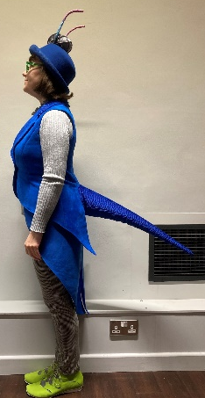  Angela plays Bill’s Grandmother in the show.

The Smeds and The Smoos - The Story
Spoiler Alert!
Below is a summary of the story which means we tell you what will happen. This might be helpful to know before you come to the theatre, but if you want the story to be a surprise then we suggest you don’t read these pages. Please don’t share these with other people as they might want the surprise too.

The Smeds and The Smoos opens with dramatic synth music and a space Caterpillar leaping from one side of the stage to the other.
Four narrators start talking about space, but they are interrupted by the sound of a baby crying. The narrators try to calm the crying baby and do so by telling the story of The Smeds and The Smoos.
The narrators introduce the red Smed Janet, who lives by a loobular lake, and Smoo Bill, who lives on a humplety hill. Grandfather Smed then jumps out with a loud ‘Honk!’ and they begin to sing a song called ♫ We are the Smeds/Smoos. Grandmother Smoo then jumps out to join the song with Bill, giving a loud ‘Aak!’ as she appears.
The Smeds and the Smoos are aliens who do not get along. As they put Janet and Bill to bed, Grandfather Smed and Grandmother Smoo warn them to never, ever play with each other.
The next morning, Janet, Grandfather Smed and Jeffrey are splashing about in their lake when Janet realises she’s bored of this watery play, and sneaks away to the Wurpular Wood.
Meanwhile, Bill, Grandmother Smoo and Betty are jumping about on the humplety hill. Bill also realises he is bored of being at home, and sneaks away like Janet!
Whilst walking through the Wurpular Wood, Janet and Bill meet. They know they are not meant to play together, but they have a brilliant time exploring the tall trockles, smelling the glompoms and playing hide and seek. As Janet finds Bill, they accidentally bump antennae and giggle.
They continue to play and laugh together, before singing a duet called ♫ Smed and Smoo.
As they nibble on the juicy and jellyful fruit of the Jerberrycoot, they are disturbed by Grandfather Smed angrily shaking his fist and Grandmother Smoo, reminding them they should never play with one another.
Years go by on their far-off planet, but Janet and Bill continue to sneak away to sing and play in the Wurpular Woods whenever they can. As they grow up, they decide to get married - but their grandparents do not approve.
That night, Janet writes a note to Bill and they come together to borrow the Smeds’ red rocket, and blast off into space!
When the families wake the next morning, they realise Janet and Bill have disappeared and that the Smeds’ red rocket is missing. Grandfather Smed, Grandmother Smoo, Jeffrey and Betty climb into the Smoos’ blue rocket and start their adventure into space to find Janet and Bill.
The first place they visit is a dry dusty planet called Vumjum. The aliens who live there - The Vums – are green and have long arms that they wave in the air. Two Vums appear from behind rocks and do the following twice through:
- Bow to the sun twice
- Bow to each other
- Tickle each other
- Do a Mexican wave
- Hug each other
The second time through, Grandmother Smoo and Grandfather Smed get in between The Vums to ask if they have seen their Janet and Bill, but they have no news.
The second planet they visit is Lurglestrop, a planet covered in colourful roses and watered by beasts that are called The Lurgles. One of The Lurgles sniffs the roses and signals Grandfather Smed and Grandmother Smoo to water the rocks, the flowers, and the audience! After their watering is done, Grandfather Smed and Grandmother Smoo ask if they have seen Janet and Bill, but the Lurgle gets confused and hides behind the hill.
The third planet they visit is Grimbletosh, which is coated in grime. After singing and jumping with the visitors (♫ Grimbletosh), The Grimbles mumble in their own words and jump into The Smoos’ rocket! The grandparents encourage them out of the rocket and put them to bed before leaving the planet.
Next, they head to planet Glurch where they find nothing but slime! A bright green alien, appears from the crater as he lures Grandfather Smed and Grandmother Smoo into his trap of slime. Betty manages to pull Grandfather Smed and Grandmother Smoo out but then gets herself stuck. Betty joins in with the final high note, which makes the green alien retreat into his crater and loosen his slime.
As they continue on their adventure, The Smoos wake one day to find they’ve run out of tea, so The Smeds offer to share their bright pink milk. Grandfather Smed also mentions his hair needs a trim, so Grandmother Smoo kindly cuts it for him.
Afterwards, they fly to Klaboo, where The Klabs walk on stilts. Then, they land on Scloop, where The Scloopies wear kilts!
They continue their search all year long, but they can’t find Janet or Bill. So, they turn and fly home to their planet where they see the pair walking in the woods together.
The blue rocket touches down and they run into the wood, embracing the runaway Smed and Smoo. Janet and Bill had got lost and flown home again, only to find the other Smeds and Smoos had left them behind. They all celebrate and hug.
Janet asks if Grandfather Smed and Grandmother Smoo would like to meet the pair’s baby. Janet and Bill show the grandparents their purple Smoo-Smed baby, with its yellow feet and small green tuft of hair. Everyone hugs and sings their celebratory party song ♫ Joy, Jam and Jumping.
As Janet and Bill take the Smoo-Smed to the cot pod and put him to sleep, everyone sings ♫ Lullaby.
They tiptoe off stage so as not to wake the snoozing baby, but it lets out a loud wail! The lights are dimmed, and the show comes to an end.
Visual Story: Your Visit to Curve
Curve is a large, round building with a glass front, as shown below.
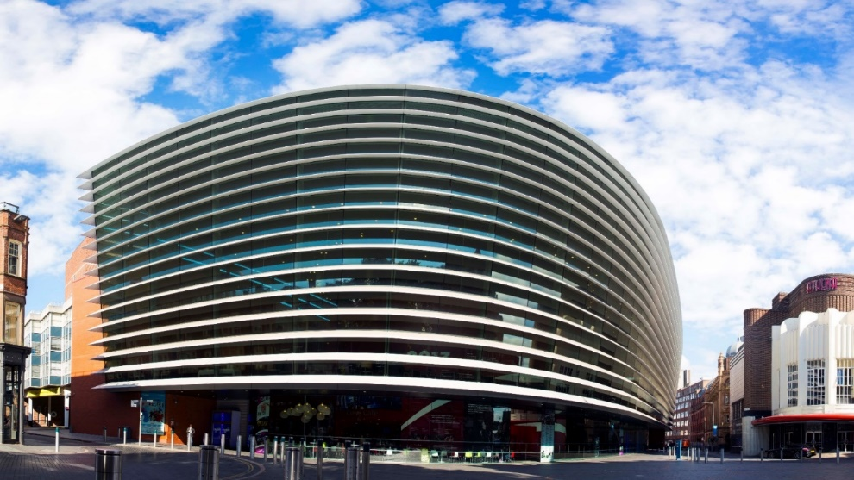
The outside of Curve looks like this:

Halford Street Entrance
what3words: ///wide.wiping.dared
Rutland Street Entrance
what3words: ///driver.other.ideal

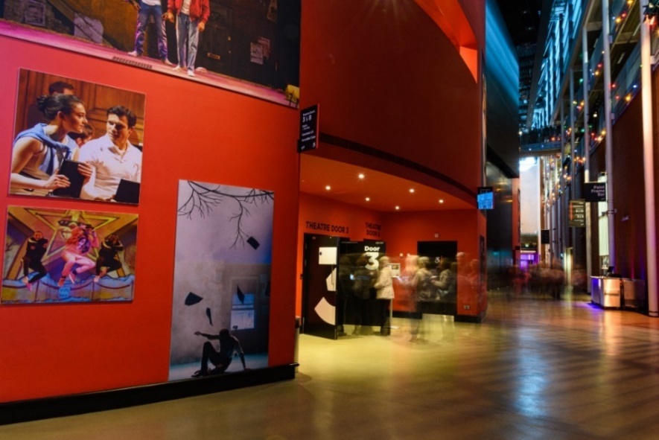
There are two main entrances into the building – one by our Green Room Café (Halford Street), and another by our Box Office (Rutland Street).
Both entrances have a set of glass double doors. Both doors can be opened by pressing the silver button on the wall or rail, but the Rutland Street doors will open outwards automatically as you move towards them.
There is level access into the building from both entrances.
When you enter the building, you will be in the Foyer. Our Foyer is one big circle which wraps around our two performance spaces – the Theatre and the Studio.
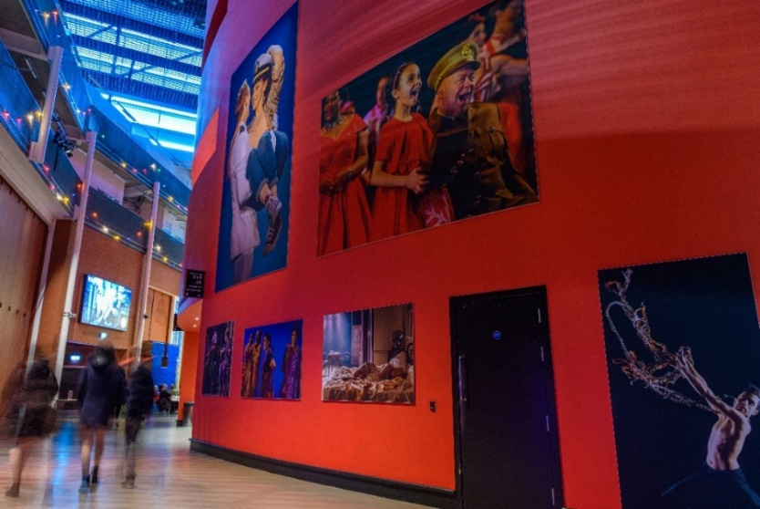
As you make your way around the Foyer, you will notice lots of large pictures on the big red walls. This is our production gallery, and features pictures from previous productions
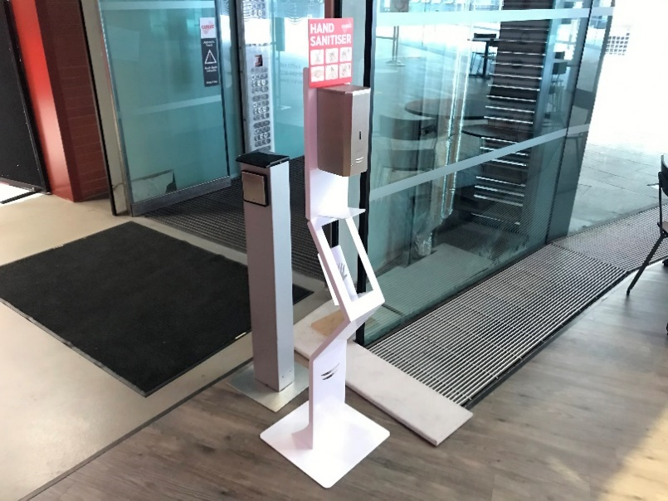 | A number of automatic hand sanitiser points are available around the building. To use these points, simply hold your hand beneath the dispenser.  A number of push dispensers are also available around the building.
Before the show and during the interval, there will be some loud announcements in the Foyer telling you how long it is until the show begins, and other useful information about your visit. These will be at a quieter level during the Relaxed Performance.
It may also be noisy in the Foyer as other audience members will be arriving to see the show. You might like to cover your ears or wear a pair of ear defenders during this time.

Widgit Symbols © Widgit Software 2002-2021, www.widgit.com
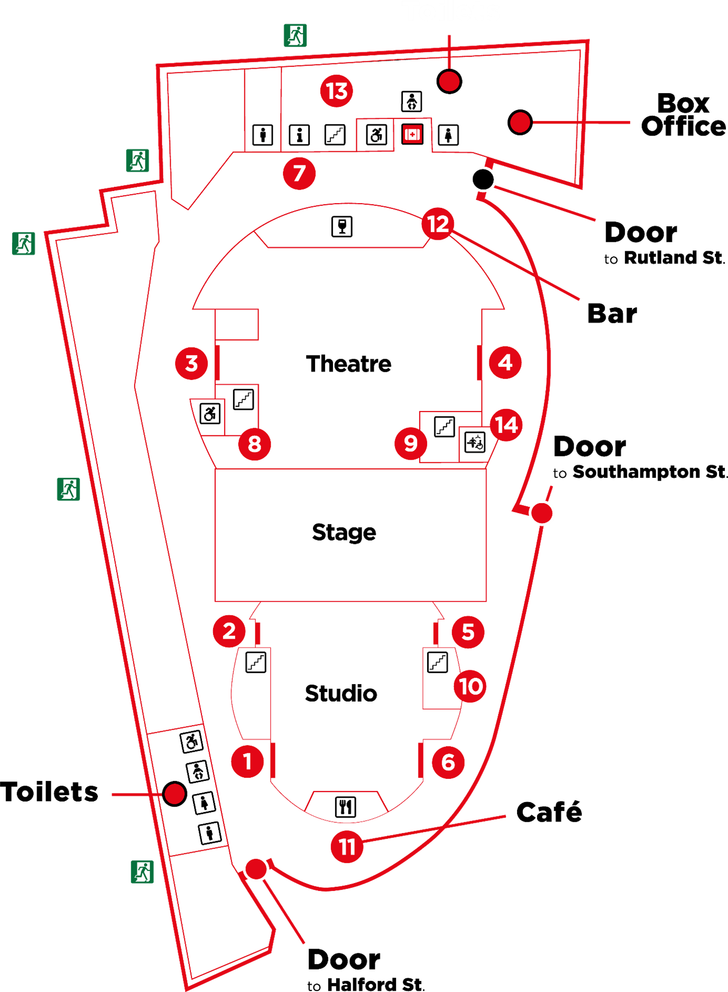
Here is a map of the Ground Floor of our Theatre.

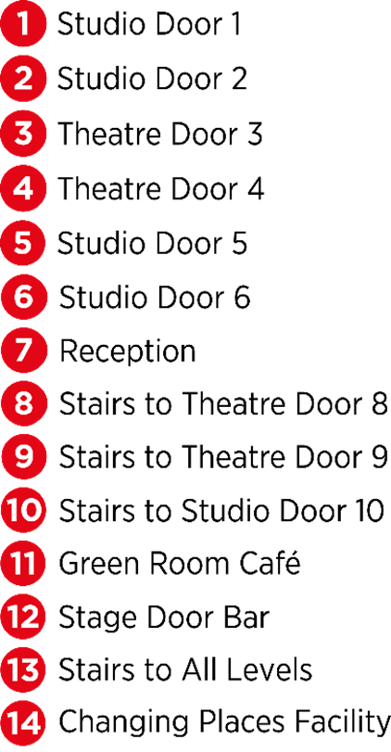

In the Foyer inside the Rutland Street doors, you will find our Box Office.
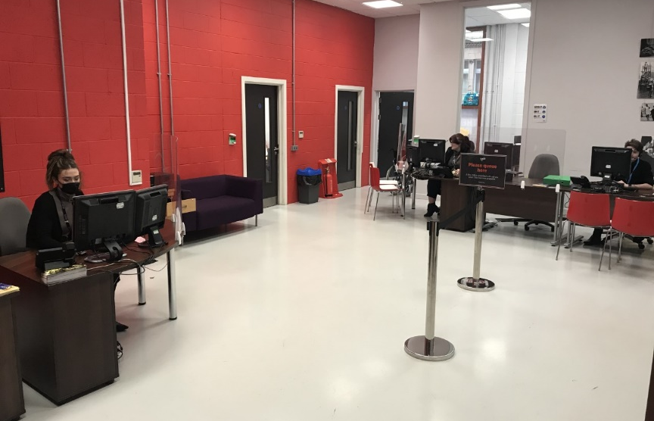
This is where you can collect your tickets for the show or buy tickets if you have not already booked.
Other audience members will also be collecting their tickets, so there might be a small queue.
Car parking tickets for cars parked in the NCP Rutland Centre Multi-storey Car Park next door to Curve can be validated at the Box Office for £5.50.

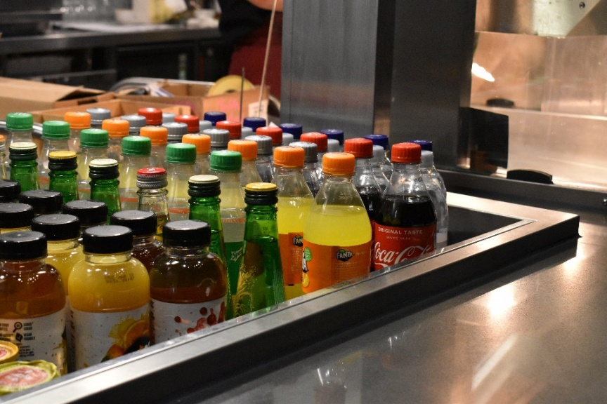
In the Foyer you will also find our Green Room Café.
Here you can buy a drink, snack or ice cream to enjoy before the performance.
There may be a small queue at the Café.

If you need to use the toilet before you take your seats, there are male, female and accessible toilets near the Green Room Café and Box Office.
All hand dryers will be turned off during the Relaxed Performance, and paper towels will be provided.
A R.A.D.A.R key is available at the Green Room Café.
The toilets look like this.

There is also a Changing Places Facility with adult hoist on the Ground Floor next to Theatre Door 4. Please note you will need to bring your own hoist straps to use this facility.

You will be watching The Smeds and The Smoos in the Studio. Here is a picture of the seats in the Studio. This is where you will sit to watch the performance.
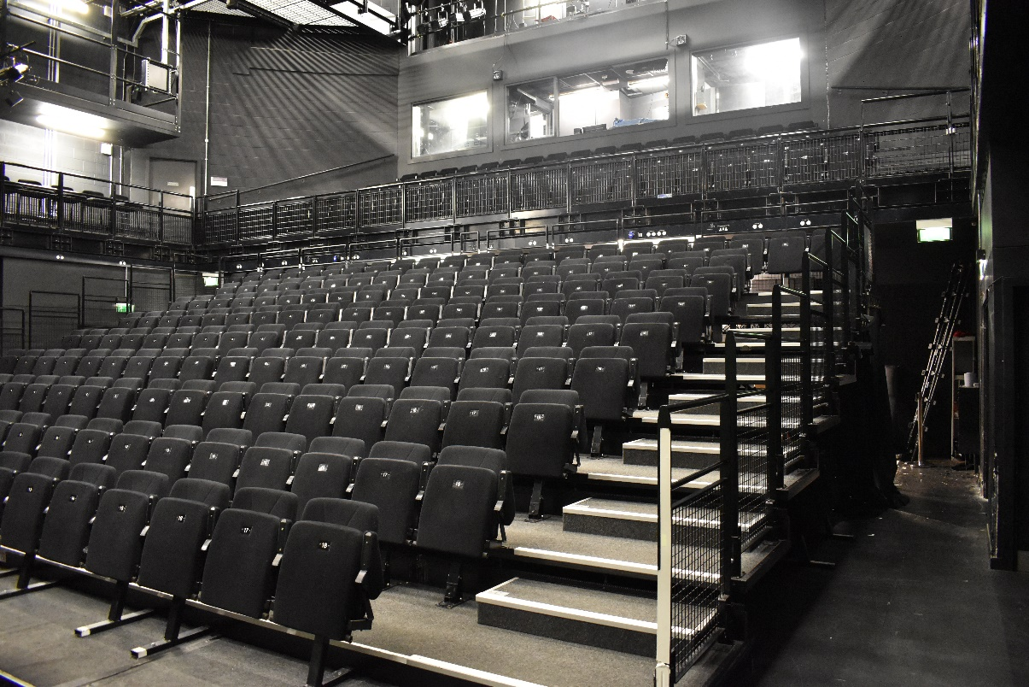

Balcony

Stalls

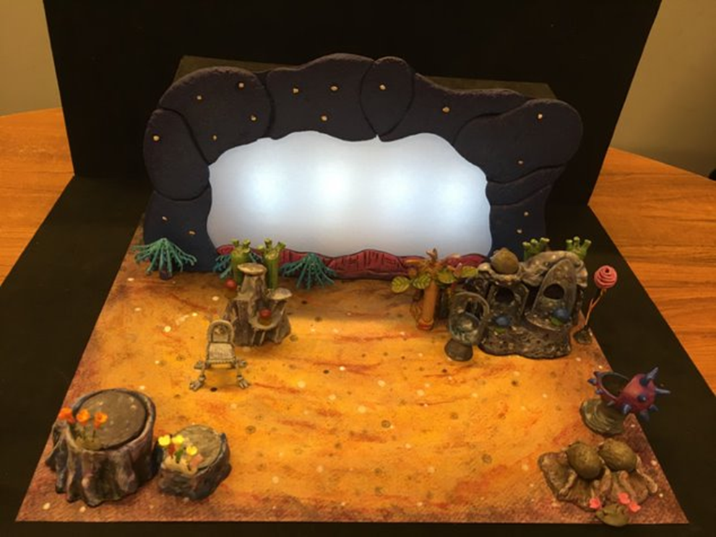
When you enter the Studio, the stage will look like the model below. The stage is the area where the actors perform the show, and the set is the name for the scenery, landscaping and objects used on the stage during the performance.

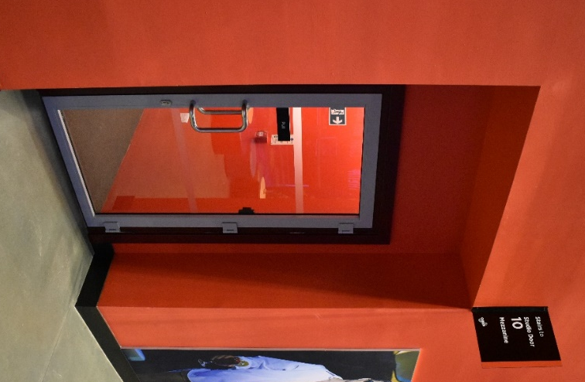
Your ticket will tell you if you are sitting in the Stalls (ground floor, enter through Studio Door 1 or 6) or in the Balcony (upstairs, enter through Studio Door 10).
Your ticket will also tell you what door to enter through and where to sit.

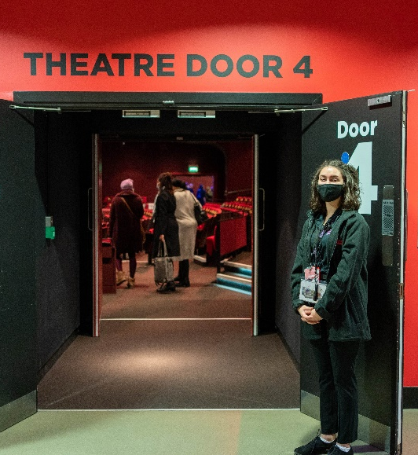
A member of our Visitor Experience Team can help you find the right door and your seat by looking at the letters and numbers on your ticket. They will be wearing black shirts with a colourful Curve logo.
When you enter the Studio, the lights will be on and it may be noisy as the audience will be excited to see the show. You might like to cover your ears or wear your ear defenders to soften the noise and bring a toy to play with before the performance starts.
You will need to pull the bottom of your seat
down to sit on it.
Booster seats are available if you can’t see the stage comfortably, and a member of our Visitor Experience Team can get one for you.
They will also be happy to help you with anything else you may need to enjoy the performance.

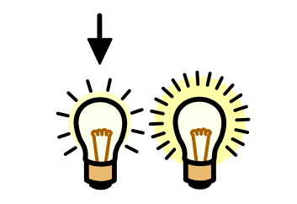
When the show is about to start, the lights in the Studio will be dimmed but it will never go completely dark.
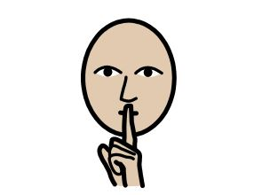
Everyone will try to be as quiet as they can so they can listen to the story and music, but you are welcome to interact with the performance if you would like to!

The doors of the Studio will remain open throughout the performance, so you can leave the space and re-enter when you’re ready should you need to use the toilet or take a break from the performance.

If you would like a break from the performance, you can visit our quiet spaces just outside the Studio, on the Mezzanine (Level M) and in Rehearsal Room 2 (RR2).
You will need to take the stairs between Studio Doors 5 and 6 to access the Mezzanine, and a member of our Visitor Experience Team can help you find it.
When the show has finished, the cast will come back onto the stage and bow. The audience will clap to show the cast they enjoyed the performance. You can also clap if you would like to!
Widgit Symbols © Widgit Software 2002-2021, www.widgit.com.
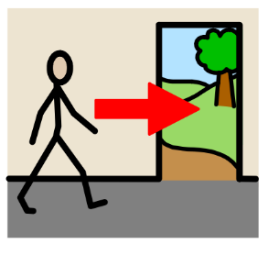
At the end of the show, the lights will get brighter.
Our Visitor Experience Team will let you know when you can exit the Studio - this is to ensure all audience members can leave the theatre safely.

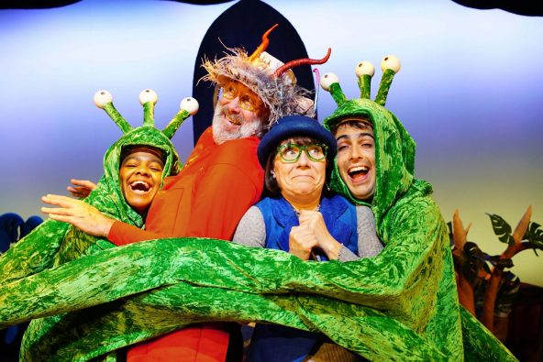
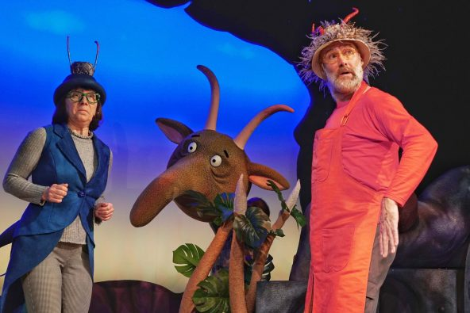
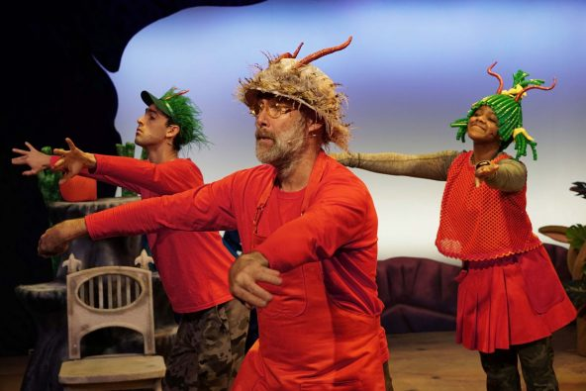
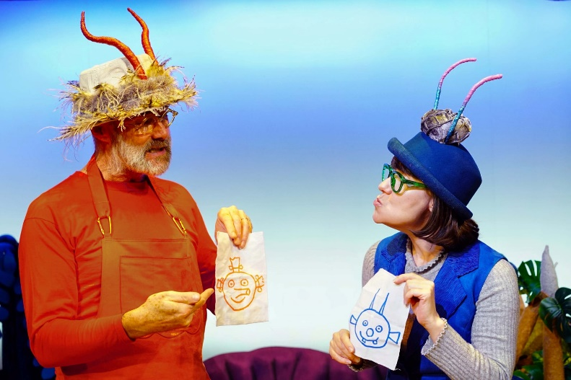
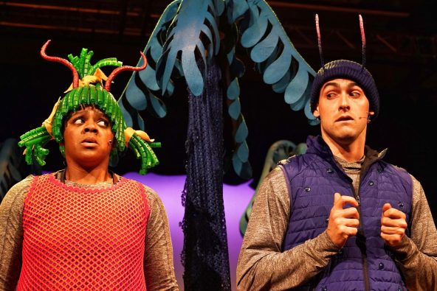
Production Gallery

Widgit Symbols © Widgit Software 2002-2021, www.widgit.com

We hope you find this information pack helpful ahead of your visit to Curve. Enjoy the show!
If you have any comments on this information pack, please email us on access@curvetheatre.co.uk.
For more information about Accessibility at Curve, please visit www.curveonline.co.uk, or call our Box Office on 0116 242 3595.
We look forward to welcoming you.

