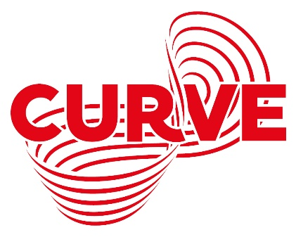

Dementia Friendly Performance Information Pack for A Chorus Line
Thursday 16 December, 2.15pm
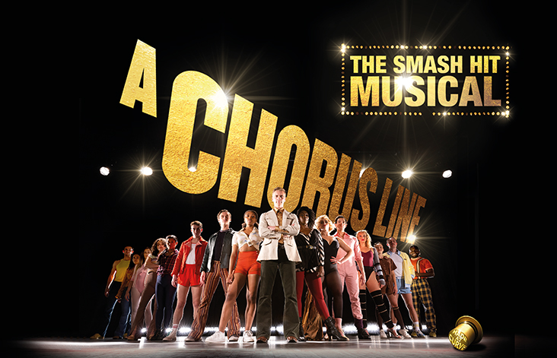
Box Office Telephone: 0116 242 3595
Box Office Email: tickets@curvetheatre.co.uk
Address: Curve, 60 Rutland Street, Leicester, LE1 1SB
Contents
Hello and What is a Dementia Friendly Performance?........................................2
Important Information for Your Visit……………………………………………………..…..3 – 4
Getting to Curve…………………………………………………………………………………………..4 - 5
About the Show………………………………………………………………………………………………..6
A Chorus Line - The Story……………………………………………………………………………7 - 10
The Cast…………………………………………………………………………………………………..11 – 12
Visual Story: Your visit to Curve…………………………………………………………….…13 - 20
Venue Map……………………………………………………………………………………………………..15
Production Gallery……………………………………..…………………………………………………..21
Hello!
We are looking forward to welcoming you to Curve for our Dementia Friendly Performance of A Chorus Line. We hope you are excited to see the show!
This pack is designed to give you a bit more information about the performance and our theatre ahead of your visit.
What is a Dementia Friendly Performance?
Our Dementia Friendly Performances are tailored to meet the specific needs of people living with Dementia. They include:
- Adaptations to the show
- Clearer visual markers and signage around the theatre
- A relaxed attitude to movement and audience responses during the show
Widgit Symbols © Widgit Software 2002-2021, www.widgit.com.
Important Information for Your Visit
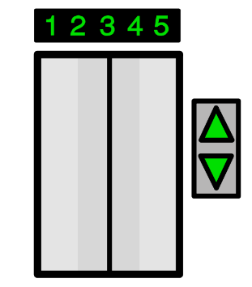
Customers are advised our public lifts at Curve are currently unavailable due to essential maintenance. Please be assured we are working with our suppliers to complete this programme of work as quickly as possible.
If you have any concerns about this in relation to your visit, please get in touch at 0116 242 3595 or e-mail tickets@curvetheatre.co.uk, where a member of our team will be happy to assist you.

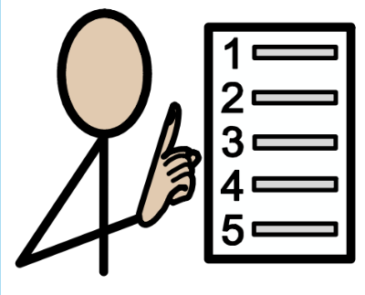
Following the latest Government updates, wearing a face covering at Curve is now mandatory for all audiences and visitors over the age of 11 years. This will apply to everyone inside the building and during every performance (except when eating or drinking). In line with the Department for Education guidelines, all school groups (Key Stage 3 and above) will also be required to wear a face covering.
We understand some people will be exempt from wearing a face covering and we ask anyone this affects to inform our Visitor Experience team members upon arrival. We also ask that you consider wearing a face shield or visor.
In addition to face coverings, we continue to have in place a number of Covid-safety measures throughout the building to ensure everyone visiting and working at Curve is as safe as possible, including increased ventilation and enhanced cleaning.
Widgit Symbols © Widgit Software 2002-2021, www.widgit.com.
Whilst it is not a requirement for entry to our building and we will not ask for proof, we encourage all audience members to take a Lateral Flow Test ahead of visiting us.
All Covid-safety measures are regularly reviewed in line with Government guidelines, please visit our website at www.curveonline.co.uk/plan-your-visit/faqs/ for further details.
Getting to Curve
Our address is Curve, 60 Rutland Street, Leicester, LE1 1SB.
Here is a map of where Curve is in the Cultural Quarter, and the surrounding area.
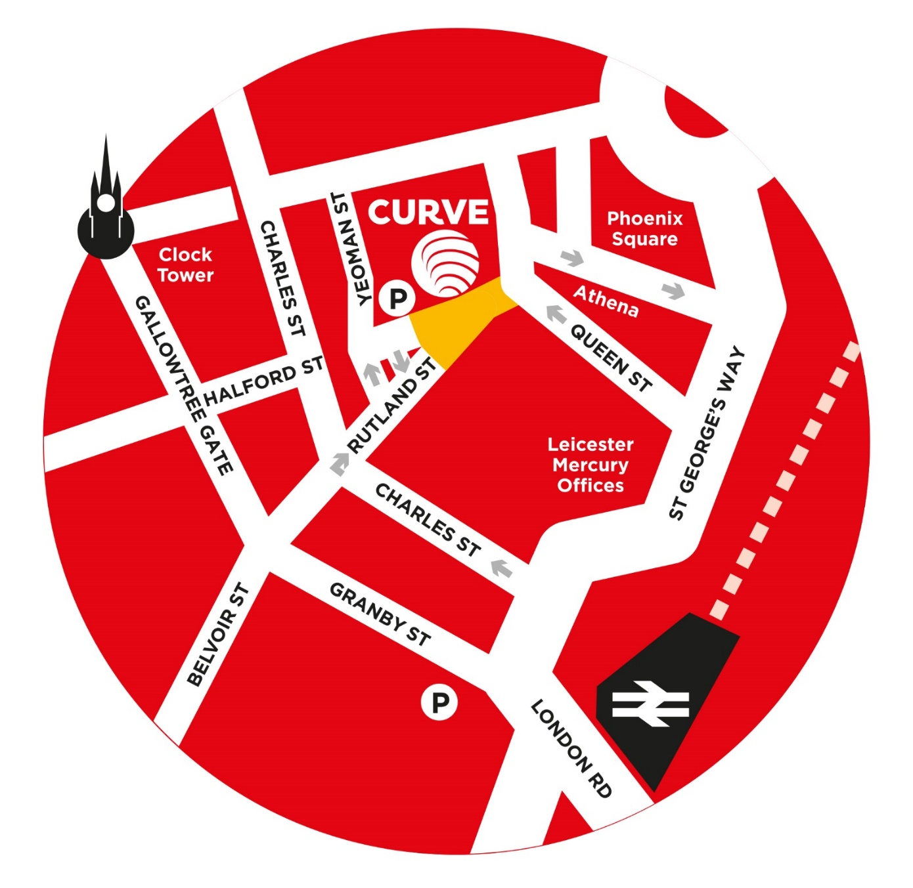

Getting here by Car
The nearest car park to Curve is the NCP Rutland Centre Multi-storey Car Park, next door to the theatre. The address for the car park is 56 Halford Street, Leicester, LE1 1TQ, and it has seven access spaces.
Visitors to Curve can park at NCP Rutland Centre Multi-storey Car Park for a reduced rate of £5.50 – please validate your car park ticket at our Box Office during your visit.
Other nearby car parks include Queen Street Car Park (LE1 1QD), NCP Lee Circle (LE1 3RE, four access spaces) and Highcross John Lewis Car Park (LE1 4QJ, 70 access spaces).
There is also a drop-off point outside our theatre.

Getting here by Bus
All Leicestershire bus services have stops within a three to 10-minute walk of Curve. Services that stop on or near Humberstone Gate or at Haymarket Bus Station are the closest.
Due to the temporary closure of St Margaret’s Bus Station, regional bus services are currently terminating at alternative stops around the city. For more information, please see www.leicester.gov.uk/media/5k3bqvgd/smbs-replacement-stops-map.pdf, or contact service providers directly for the latest information on your service.
For more information on your nearest bus stop, visit the Leicester City Council website at www.leicester.gov.uk/transport-and-streets/travelling-by-bus/, or call Traveline on 0871 200 2233.
Getting here by Train
Leicester Train Station is less than a 10-minute walk away via Charles Street. For the latest service information, please visit www.nationalrail.co.uk.

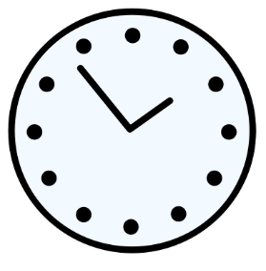
About the Show
This production contains smoke and haze, flashing lights, pyrotechnics, strong language and sexual references throughout.
The approximate running time for A Chorus Line is 1 hour and 50 minutes.
There will not be an interval during this performance.
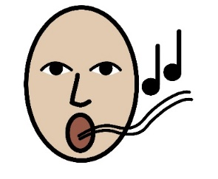
The performance will start at 2.15pm, and finish at approximately 4.05pm.
A Chorus Line is a musical, so there will be lots of singing and dancing throughout the performance. You can dance along during the show too if you would like to!
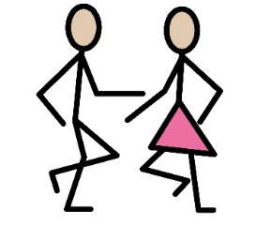
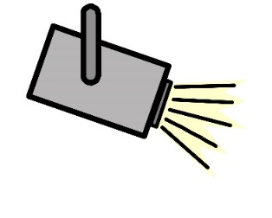
The music in the show is performed live by an eight-piece band, conducted by our Musical Director Tamara Saringer and sung by members of the company.
There will be different lighting states throughout the performance, with some moments in brighter lighting and other moments in darker lighting. There will also be some flashing lights. The lights in the auditorium will remain on at a low-level during the show.
At several moments during the performance, the Director – Zach, played by Adam Cooper - will walk off the stage, up the aisles and into the auditorium to put his questions to the company via a handheld microphone.
You will hear his voice, but you may not see him depending where you are sitting in the theatre. He will then return to the stage to re-join the company.
Widgit Symbols © Widgit Software 2002-2021, www.widgit.com.

A Chorus Line – The Story
Spoiler Alert!
Below is a summary of the story of A Chorus Line. This might be helpful to know before you come to the theatre, but if you want the story to be a surprise then we suggest you don’t read these pages. Please don’t share these with other people as they might want the surprise too.

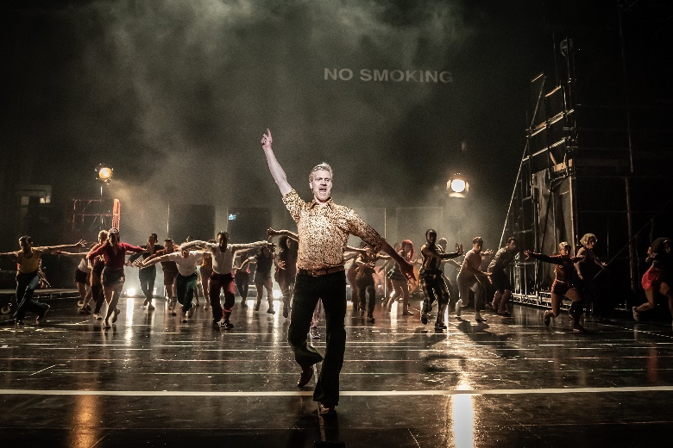
Set in 1975 in a Broadway theatre in New York City, New York, A Chorus Line opens on an audition for a new Broadway musical. The iron safety curtain slowly lifts to reveal 27 dancers being put through their paces by the show’s Director Zach and his assistant, Larry.
Each of the performers is determined to get this job, their desperation told through the show’s opening number ♫ I Hope I Get It. The first round of cuts sees ten dancers leave the audition, with 17 still in the running for eight places that are available on the chorus line – four boys and four girls.
Zach is keen to find out more about his potential chorus dancers and invites each of the auditionees to introduce themselves and their backgrounds. Over the course of the musical we learn more about each of them - their childhoods, their teenage years, and their on-stage careers so far.
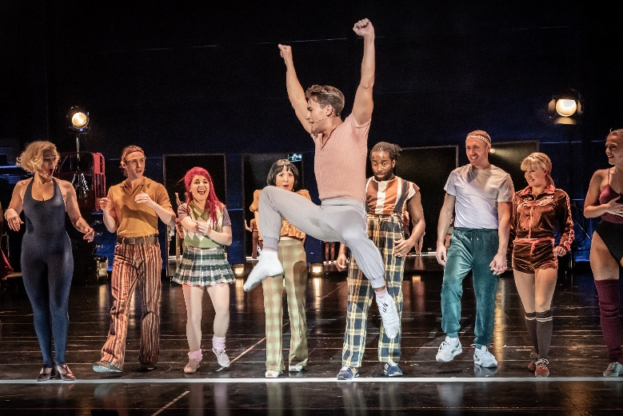
Mike Costa is the first to share his story. The youngest in his family, Mike shares his first encounter with performing after taking his sister’s place in her dance class (♫ I Can Do That).

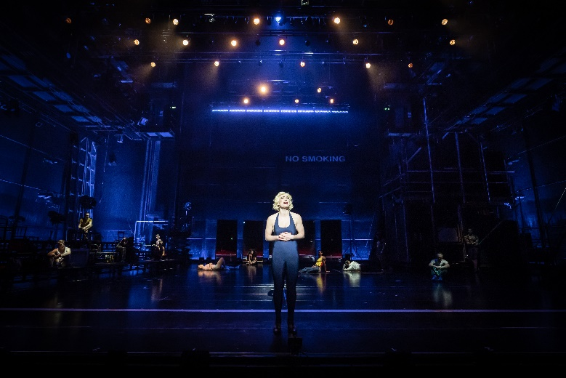
Next up is Bobby Mills, who uses humour to make light of a challenging childhood. His speech is frequently interrupted by other dancers on the line who are panicking about what and how much they should share with Zach during this part of the audition (♫ … And…).
After Bobby, Zach asks Sheila Bryant to talk. Initially, she flirts with Zach but then shares details of her parents’ troubled marriage at a young age, and her father’s controlling personality. Aged six, she found ballet to be her escape from life at home (♫ At the Ballet); fellow dancers Bebe Benzenheimer and Maggie Winslow join her for the number, having also experienced difficulties at home.
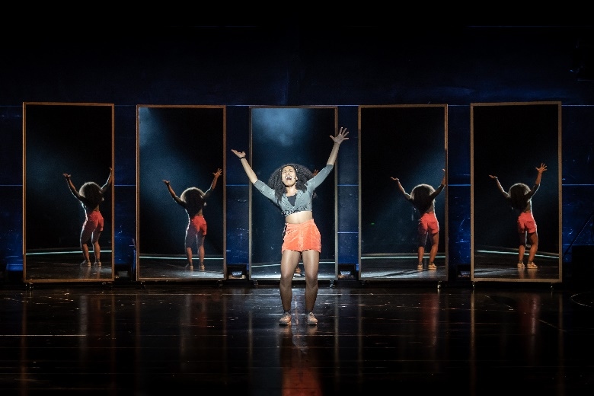
Married couple Kristine Urich and her husband Al Deluca are next to step forward. Ditzy Kristine is a brilliant dancer but isn’t quite as fortunate with her vocals, so she chooses to share her struggles with singing as Al finishes each of her sentences (♫ Sing!)
The audition then switches focus to the dancers’ adolescent years (♫ Hello Twelve, Hello Thirteen, Hello Love). The youngest dancer, Mark Anthony, shares his first experience of the female form after finding a medical textbook in his father’s library. Petite Connie Wong follows him to discuss the troubles of being 4’10” whilst Diana Morales shares her difficulties in finding emotion during her high school acting classes
(♫ Nothing).
As Don Kerr recounts stories from a previous job in a nightclub, the other dancers interrupt with memories of their younger years (♫ Mother). Judy Turner is also interrupted as she revisits her childhood, including the jibes made by her mother after-school and practicing kissing with another girl.
After Judy, Gregory Gardner reflects on coming out, whilst Richie Walters remembers his potential career path into kindergarten teaching (♫ Gimme the Ball).
Val Clark then steps forward. She shares a story of being marked in a previous audition as top for dancing but lower for her looks, before telling her fellow dancers that improving their image with plastic surgery can widen their career prospects – and that talent isn’t everything in the industry (♫ Dance: Ten, Looks: Three).
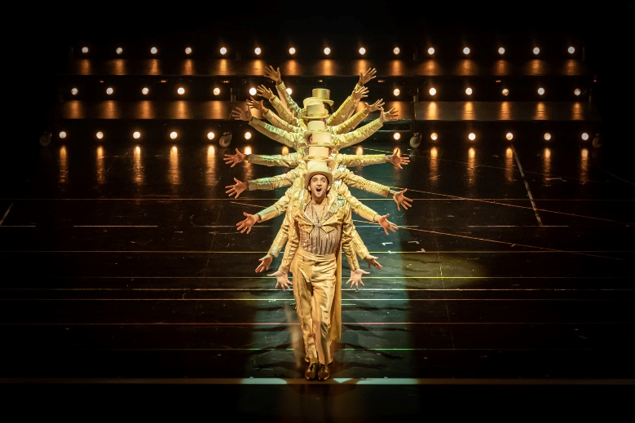
Last to the line is Paul San Marco. Paul is still hesitant about what to share, and Zach’s prompts don’t get much of a response until he asks questions about his family. It is clear the questions are uncomfortable for Paul, so Zach puts the group on a break with Larry to learn the next routine.
Experienced dancer Cassie remains on stage with Zach, and tensions from their past relationship quickly re-emerge. Zach insists she’s too talented to be just a chorus dancer, but she’s having trouble finding work as a soloist and just wants to dance (♫ The Music and the Mirror). Zach sends her to join the other dancers downstairs.
Zach then requests that Paul San Marco re-join him on the empty stage. Paul gets emotional as he discusses his younger years, his time as a drag artist and the secrets he tried to keep from his parents. Zach comforts him as he begins to sob, and the dancers return to run through the next number (♫ One Rehearsal).
Over the course of the routine, Zach and Cassie talk through the flaws in their relationship. He accuses her of not dancing to her full potential and asks if she really wants to be part of the line; she insists she would be proud to dance among them.
In the next tap sequence (♫ Tap Dance), Paul trips and hurts his knee. Larry and Don carry him off stage to go to the hospital, as the other dancers realise their careers could also come to an end at a moment’s notice. This prompts Zach to ask the group what they will do when dancing is no longer an option (♫ What I Did For Love), before selecting his eight dancers, who are Mike, Cassie, Bobby, Judy, Richie, Val, Mark and Diana.
A lone, male chorus dancer then takes to the dark stage beneath a single spotlight, wearing a gold top hat and golden, sparkly tails. After a few moments of dancing solo, other members of the chorus join him on stage in similar outfits for the start of the finale number, ♫ One.
Several lighting rigs filled with warm white lights lower into view as the company perform the song, dancing into an array of neat formations. As the number draws to a close, the iron safety curtain lowers back onto the stage signalling the end of the performance.

The Cast
There are 23 actors in our production of A Chorus Line. You can meet the company in the pictures below.
The actors’ real names are in bold, with their character beneath:
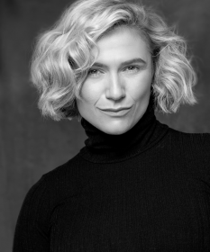 | 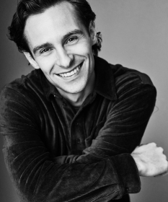 | 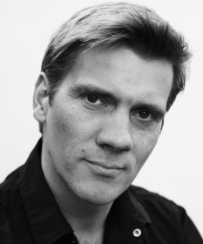 | 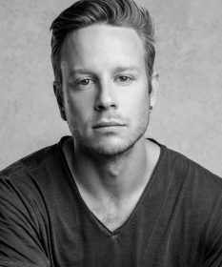
Emily Barnett-Salter  Sheila Bryant | Ronan Burns  Bobby Mills | Adam Cooper  Zach | Eamonn Cox  Swing
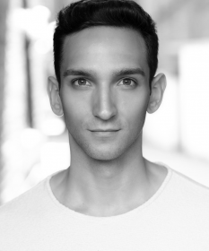 | 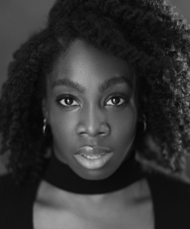
Bradley Delarosbel  Gregory Gardner | Carly Mercedes Dyer  Cassie | Lizzy-Rose Esin-Kelly  Diana Morales | Andre Fabien Francis  Richie Walters
 | 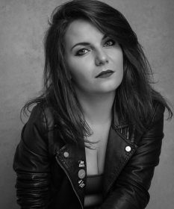 | 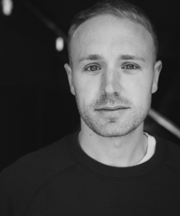 | 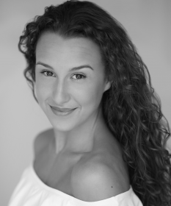
Ainsley Hall Ricketts  Paul San Marco | Beth Hinton-Lever  Bebe Benzenheimer | Joshua Lay  Al Deluca | Katie Lee  Kristine Urich
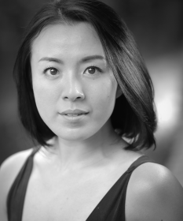 |  | 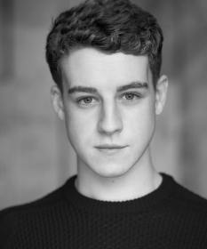 | 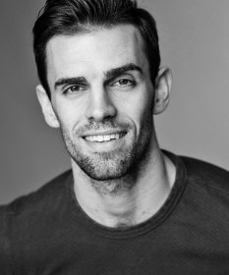
Kanako Nakano  Judy Turner | Hicaro Nicolai  Swing | Jamie O’Leary  Mark Anthony | Tom Partridge  Don Kerr
 | 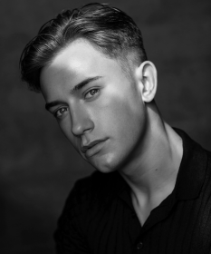 |  | 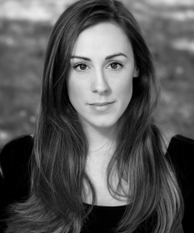
Rachel Jayne Picar  Connie Wong | Redmand Rance  Mike Costa | Chloe Saunders  Val Clarke | Charlotte Scott  Maggie Winslow
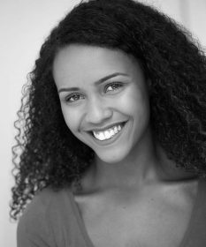 | 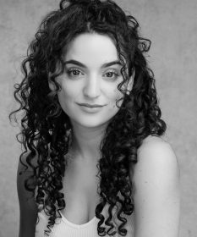
Hollie Smith-Nelson  Swing | Marina Tavolieri  Swing | Taylor Walker  Larry, Zach’s Assistant
There is also a young ensemble in our production, who are split into two teams of ten performers. You will see the younger cast members in the audition at the start of the show also trying out for a place on the chorus line.

Visual Story: Your Visit to Curve
Curve is a large, round building with a glass front, as shown below.
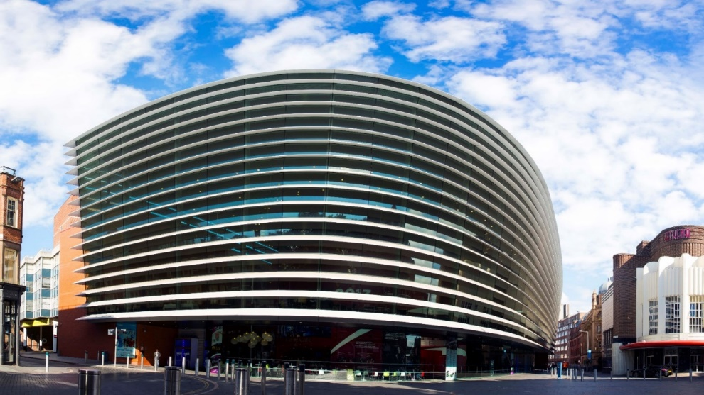
The outside of Curve looks like this:

Halford Street Entrance
what3words: ///wide.wiping.dared
Rutland Street Entrance
what3words: ///driver.other.ideal

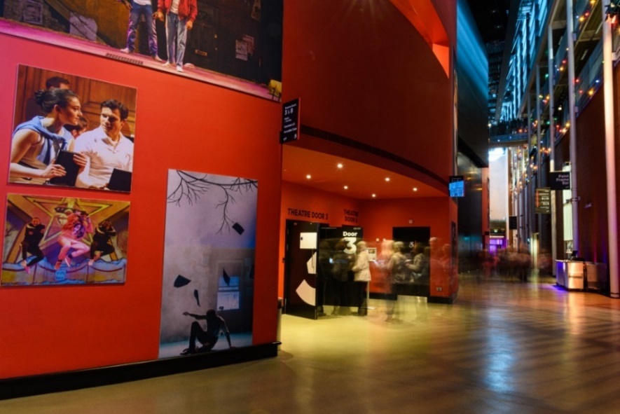
There are two main entrances into the building – one by our Green Room Café (Halford Street), and another by our Box Office (Rutland Street).
Both entrances have a set of glass double doors. Both doors can be opened by pressing the silver button on the wall or rail, but the Rutland Street doors will open outwards automatically as you move towards them.
There is level access into the building from both entrances.
When you enter the building, you will be in the Foyer. Our Foyer is one big circle which wraps around our two performance spaces – the Theatre and the Studio.
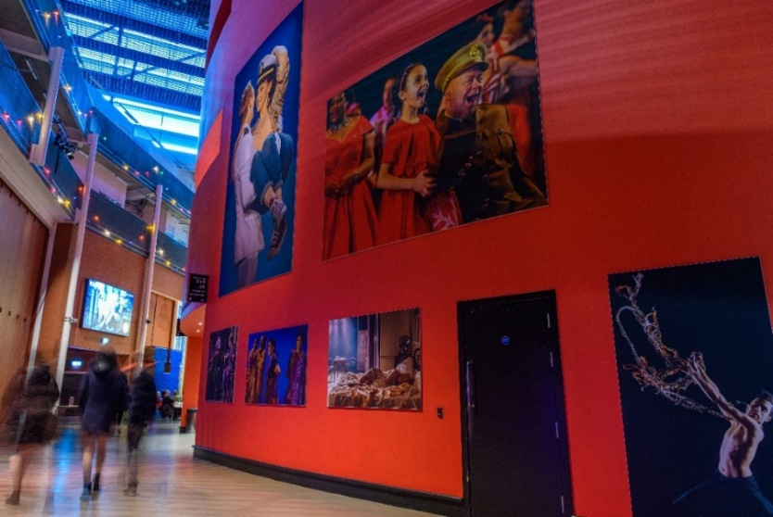
As you make your way around the Foyer, you will notice lots of large pictures on the big red walls. This is our production gallery, and features pictures from previous productions here at Curve.
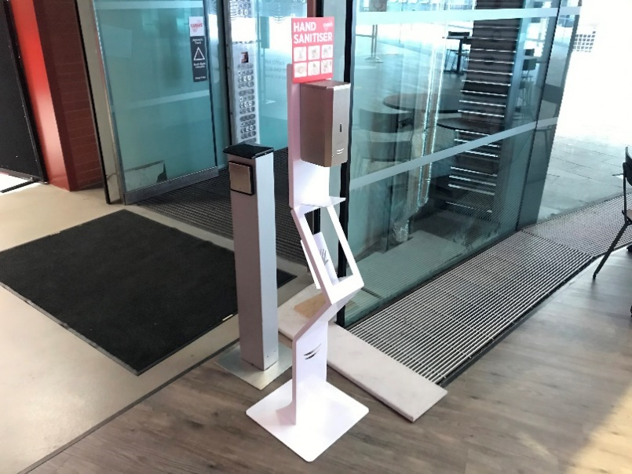 | A number of automatic hand sanitiser points are available around the building. To use these points, simply hold your hand beneath the dispenser.  A number of push dispensers are also available around the building.
Before the show, there will be some loud announcements in the Foyer telling you how long it is until the show begins, and other useful information about your visit. These will be at a quieter level during the Dementia Friendly performance.
It may also be noisy in the Foyer as other audience members will be arriving to see the show.

Widgit Symbols © Widgit Software 2002-2021, www.widgit.com
Here is a map of the Ground Floor of our Theatre.
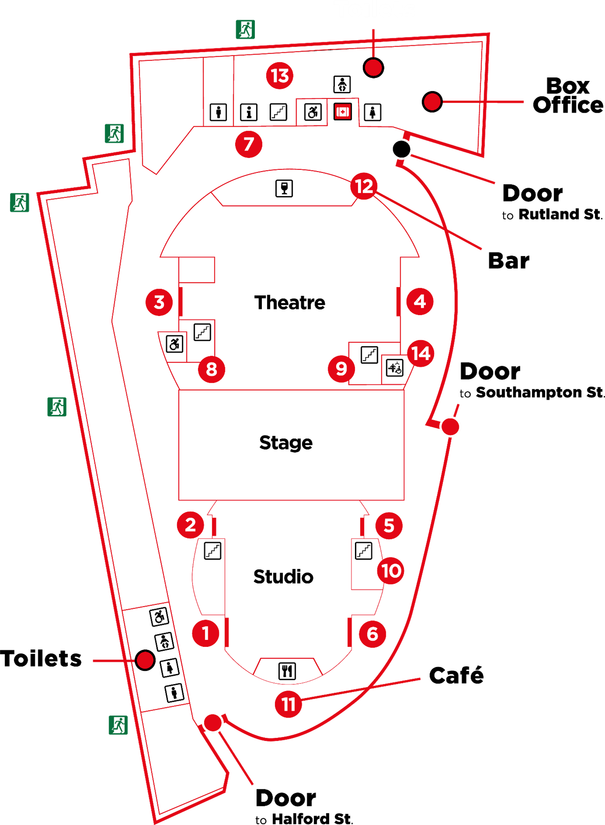

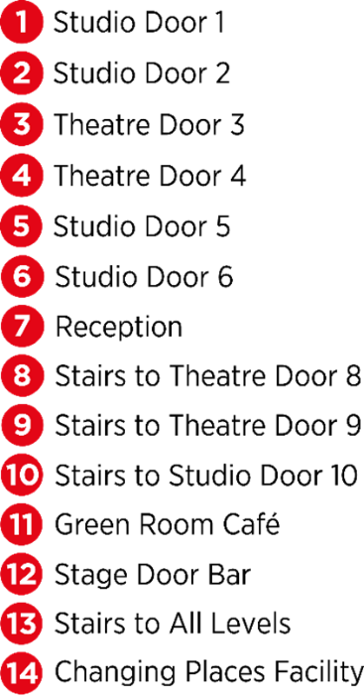

In the Foyer inside the Rutland Street doors, you will find our Box Office.
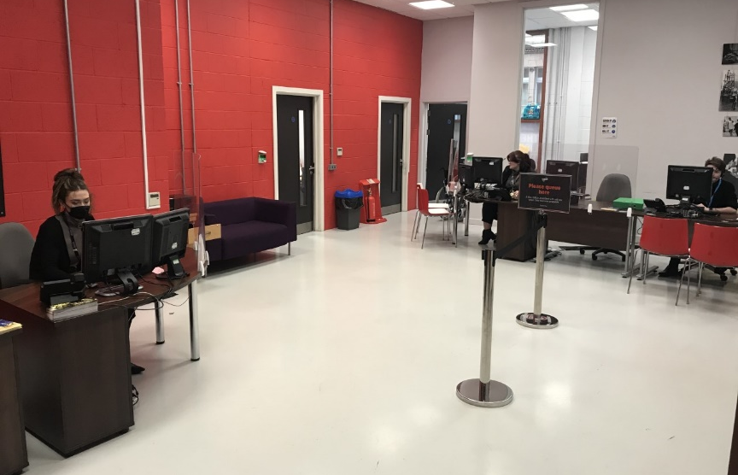
This is where you can collect your tickets for the show or buy tickets if you have not already booked.
Other audience members will also be collecting their tickets, so there might be a small queue.
Car parking tickets for cars parked in the NCP Rutland Centre Multi-storey Car Park next door to Curve can be validated at the Box Office for £5.50.
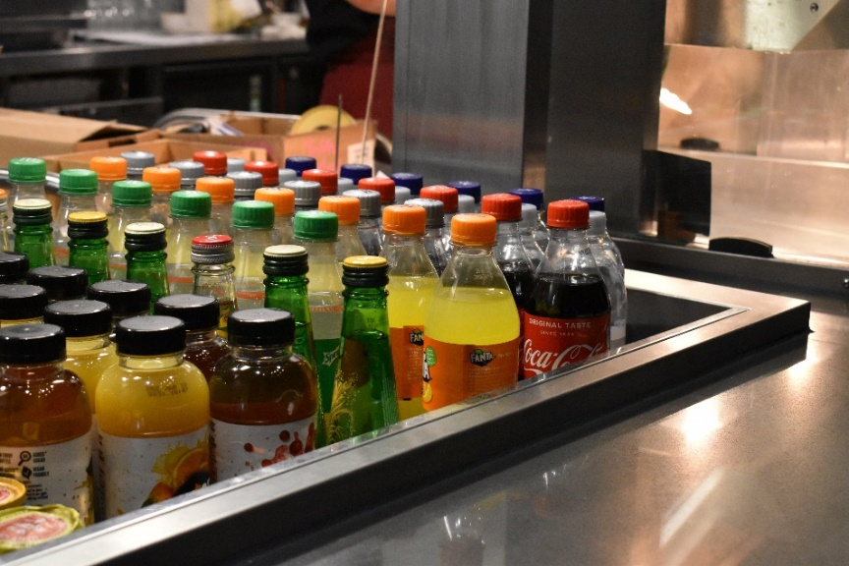
In the Foyer you will also find our Green Room Café.
Here you can buy a drink, snack or ice cream to enjoy before the performance.
There may be a small queue at the Café.

If you need to use the toilet before you take your seats, there are male, female and accessible toilets near the Green Room Café and Box Office.
A R.A.D.A.R key is also available at the Green Room Café.

The toilets look like this.

There is also a Changing Places Facility with adult hoist on the Ground Floor next to Theatre Door 4. Please note you will need to bring your own hoist straps to use this facility.

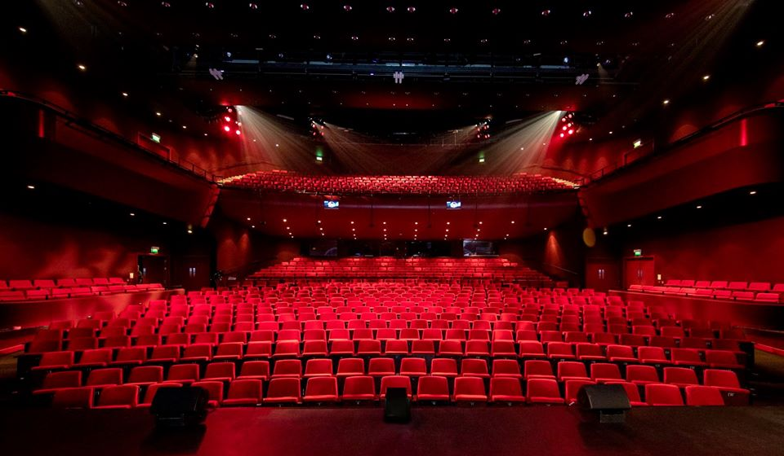
You will be watching A Chorus Line in the Theatre. Here is a picture of the seats in the Theatre. This is where you will sit to watch the performance.
Circle
Stalls
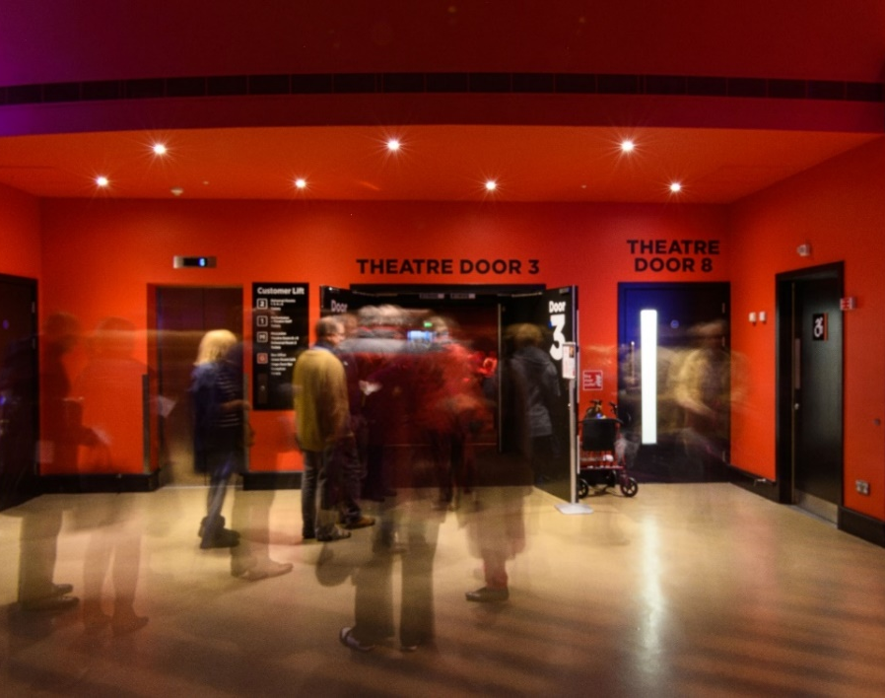
Your ticket will tell you if you are sitting in the Stalls (ground floor, enter through Theatre Door 3 or 4) or in the Circle (upstairs, enter through Theatre Door 8 or 9). Your ticket will also tell you what door to enter through and where to sit.

If you are sat in the Circle, you will have to take the stairs next to Theatre Door 3 or 4 to access Theatre Door 8 or 9 on the Mezzanine floor (Level M). The staircase next to Theatre Door 3 has 31 steps over three flights (9, 11, 11) and the staircase next to Theatre Door 4 also has 31 steps over three flights (13, 7, 11). There is a landing between each flight of stairs.
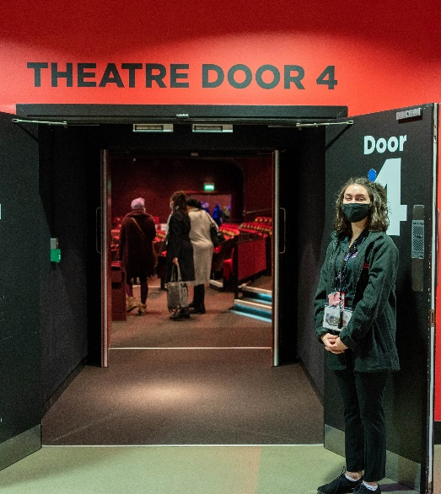
A member of our Visitor Experience Team can help you find the right door and your seat by looking at the letters and numbers on your ticket. They will be wearing black shirts with a colourful Curve logo.
When you enter the Theatre, the lights will be on and it may be noisy as the audience will be excited to see the show.

You will need to pull the bottom of your seat
down to sit on it.
Booster seats are available if you can’t see the stage comfortably, and a member of our Visitor Experience Team can get one for you.
They will also be happy to help you with anything else you may need to enjoy the performance.

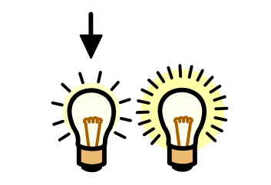
When the show is about to start, the lights in the Theatre will be dimmed but it will never go completely dark.
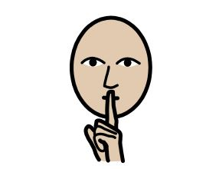
Everyone will try to be as quiet as they can so they can listen to the story and music, but you are welcome to interact with the performance if you would like to!

Widgit Symbols © Widgit Software 2002-2021, www.widgit.com
Whilst the internal doors to the Theatre will close, the outer doors will remain open throughout the performance, so you can leave the space and re-enter when you’re ready should you need to use the toilet or take a break from the performance.
If you would like a break from the performance, you are welcome to take a seat in our Foyer. Alternatively, you can visit our quiet spaces on the Mezzanine (Level M), and in Rehearsal Room 2 (RR2).
You will need to take the stairs next to Theatre Door 3 or 4 to access the Mezzanine, and a member of our Visitor Experience Team can help you find your way.

When the show has finished, the cast will come back onto the stage and bow. The audience will clap to show the cast they enjoyed the performance. You can also clap if you would like to!

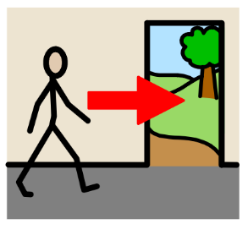
The lights will then get brighter, and our Visitor Experience Team will let you know when you can exit the Theatre. This is to ensure all audience members can leave the theatre safely.

However, you are also welcome to remain in the auditorium after the performance for a short meet and greet with the company. The company will chat to you from a safe distance and will also be wearing masks to ensure everyone’s safety.
Widgit Symbols © Widgit Software 2002-2021, www.widgit.com.
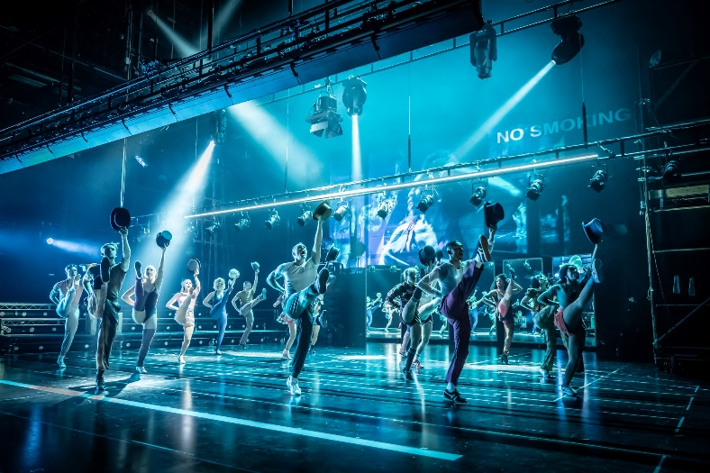
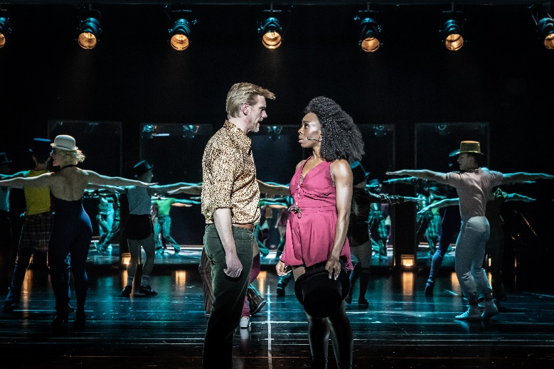
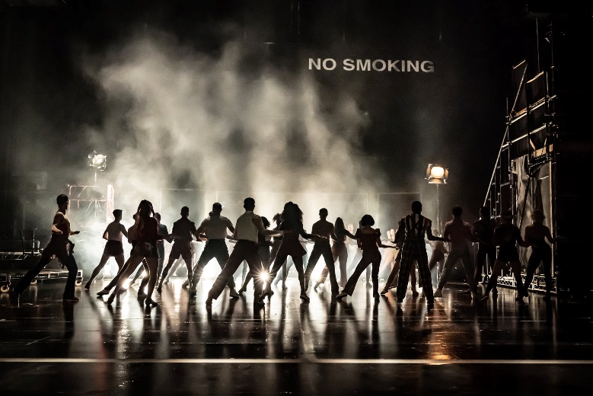
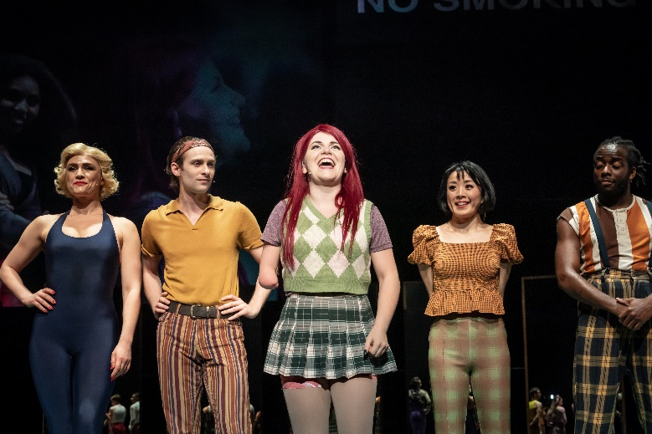
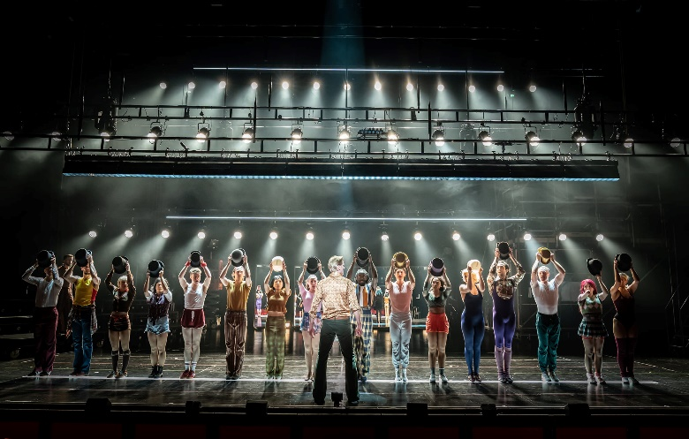
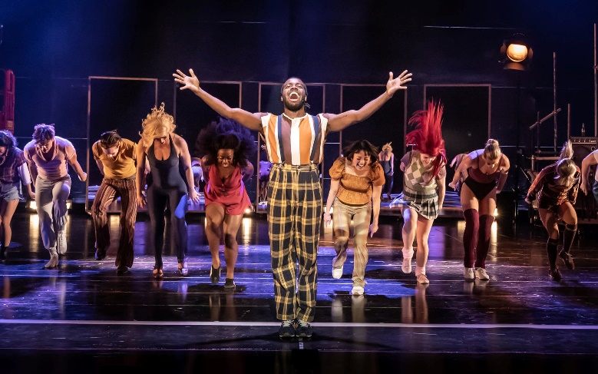
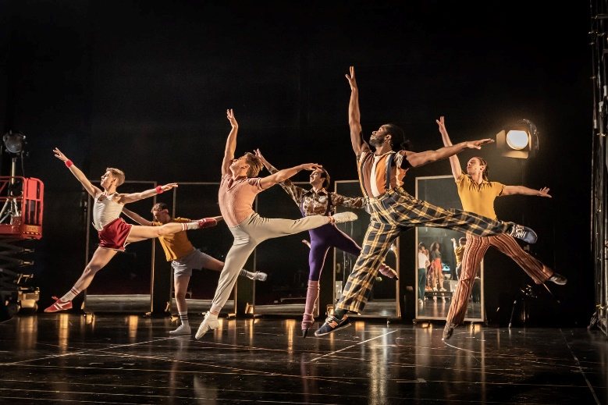
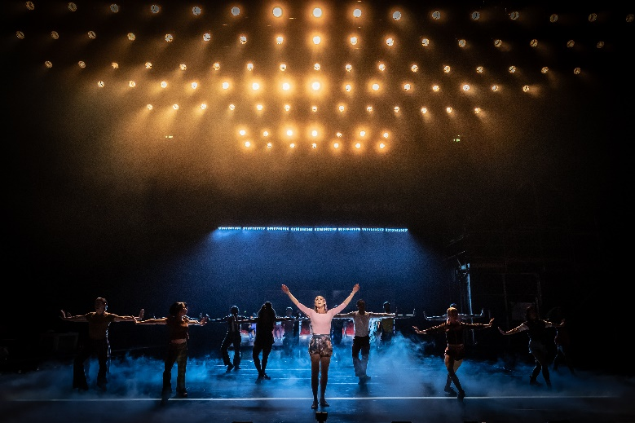
Production Gallery – Photos by Marc Brenner

We hope you find this information pack helpful ahead of your visit to Curve.
If you have any comments on this information pack, please email us on access@curvetheatre.co.uk.
For more information about Accessibility at Curve, please visit www.curveonline.co.uk, or call our Box Office on 0116 242 3595.
We look forward to welcoming you!
Artwork Photography: Ellie Kurttz
Production Photography: Marc Brenner

