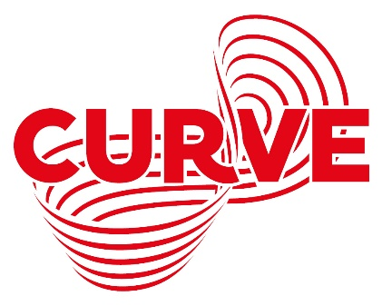

Relaxed Performance Information Pack for
What the Ladybird Heard
Friday 1 October, 1.30pm
Sunday 3 October, 1.30pm
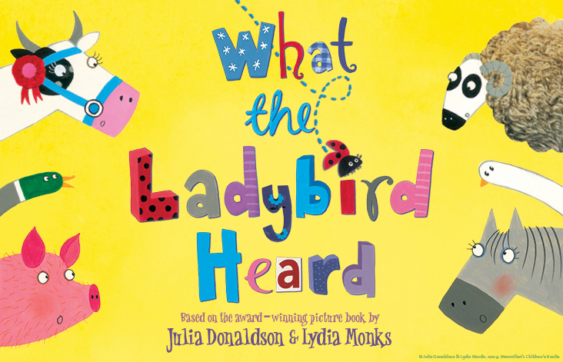
Box Office Telephone: 0116 242 3595
Box Office Email: tickets@curvetheatre.co.uk
Address: Curve, 60 Rutland Street, Leicester, LE1 1SB

Contents
Hello and Your Safety at Curve…………………………………………………………………….2 - 3
Getting to Curve……………………………………………………………………...…………………..4 - 5
About the Show and Things to Look Out For………………………….…..….……………6 - 7
The Cast…………………………………………………………………………………….…….…………..8 - 9
What the Ladybird Heard – The Story………………………………..…….……………..10 - 12
Visual Story: Your Visit to Curve………………………………………..…….………………13 - 21
Production Gallery………………………………………………………………………………………….21

Hello!
We are looking forward to welcoming you to Curve for our Relaxed Performance of What the Ladybird Heard. We hope you are excited to see the show!
This pack is designed to give you a bit more information about the performance and our theatre ahead of your visit.
What is a Relaxed Performance?
Relaxed Performances are open to everyone but are especially tailored to support audiences with additional needs who may benefit from a more relaxed performance environment. This can include children, young people and adults with neurodivergence, such as autism, learning difficulties and other sensory or communication needs.
Throughout the performance the lights will remain on, and whilst the Studio doors will be closed, audience members will be free to come and go from the Studio if they need a break from the performance. There is also a relaxed attitude to noise during the show, and the sound and lighting will be adapted to more comfortable levels.
Widgit Symbols © Widgit Software 2002-2021, www.widgit.com.
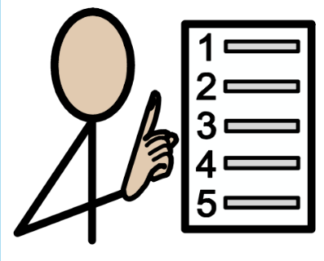
Your Safety at Curve

To welcome audience members back to Curve at full capacity safely, we have a number of measures in place throughout our building.

This includes continuing to ask audience members who are medically able to wear face coverings around the building and during the performance.

However, we understand that for health and wellbeing reasons some people cannot wear face coverings. If you or a member of your party are unable to wear a face covering, please notify a member of staff upon arrival who will be able to assist.

There will also be automatic temperature checks on arrival, increased ventilation throughout your visit and additional cleaning between performances.

For more information on what to expect from your visit, please visit www.curveonline.co.uk/re-opening-faqs/

Widgit Symbols © Widgit Software 2002-2021, www.widgit.com.
Getting to Curve
Our address is Curve, 60 Rutland Street, Leicester, LE1 1SB.
Here is a map of where Curve is in the Cultural Quarter, and the surrounding area.
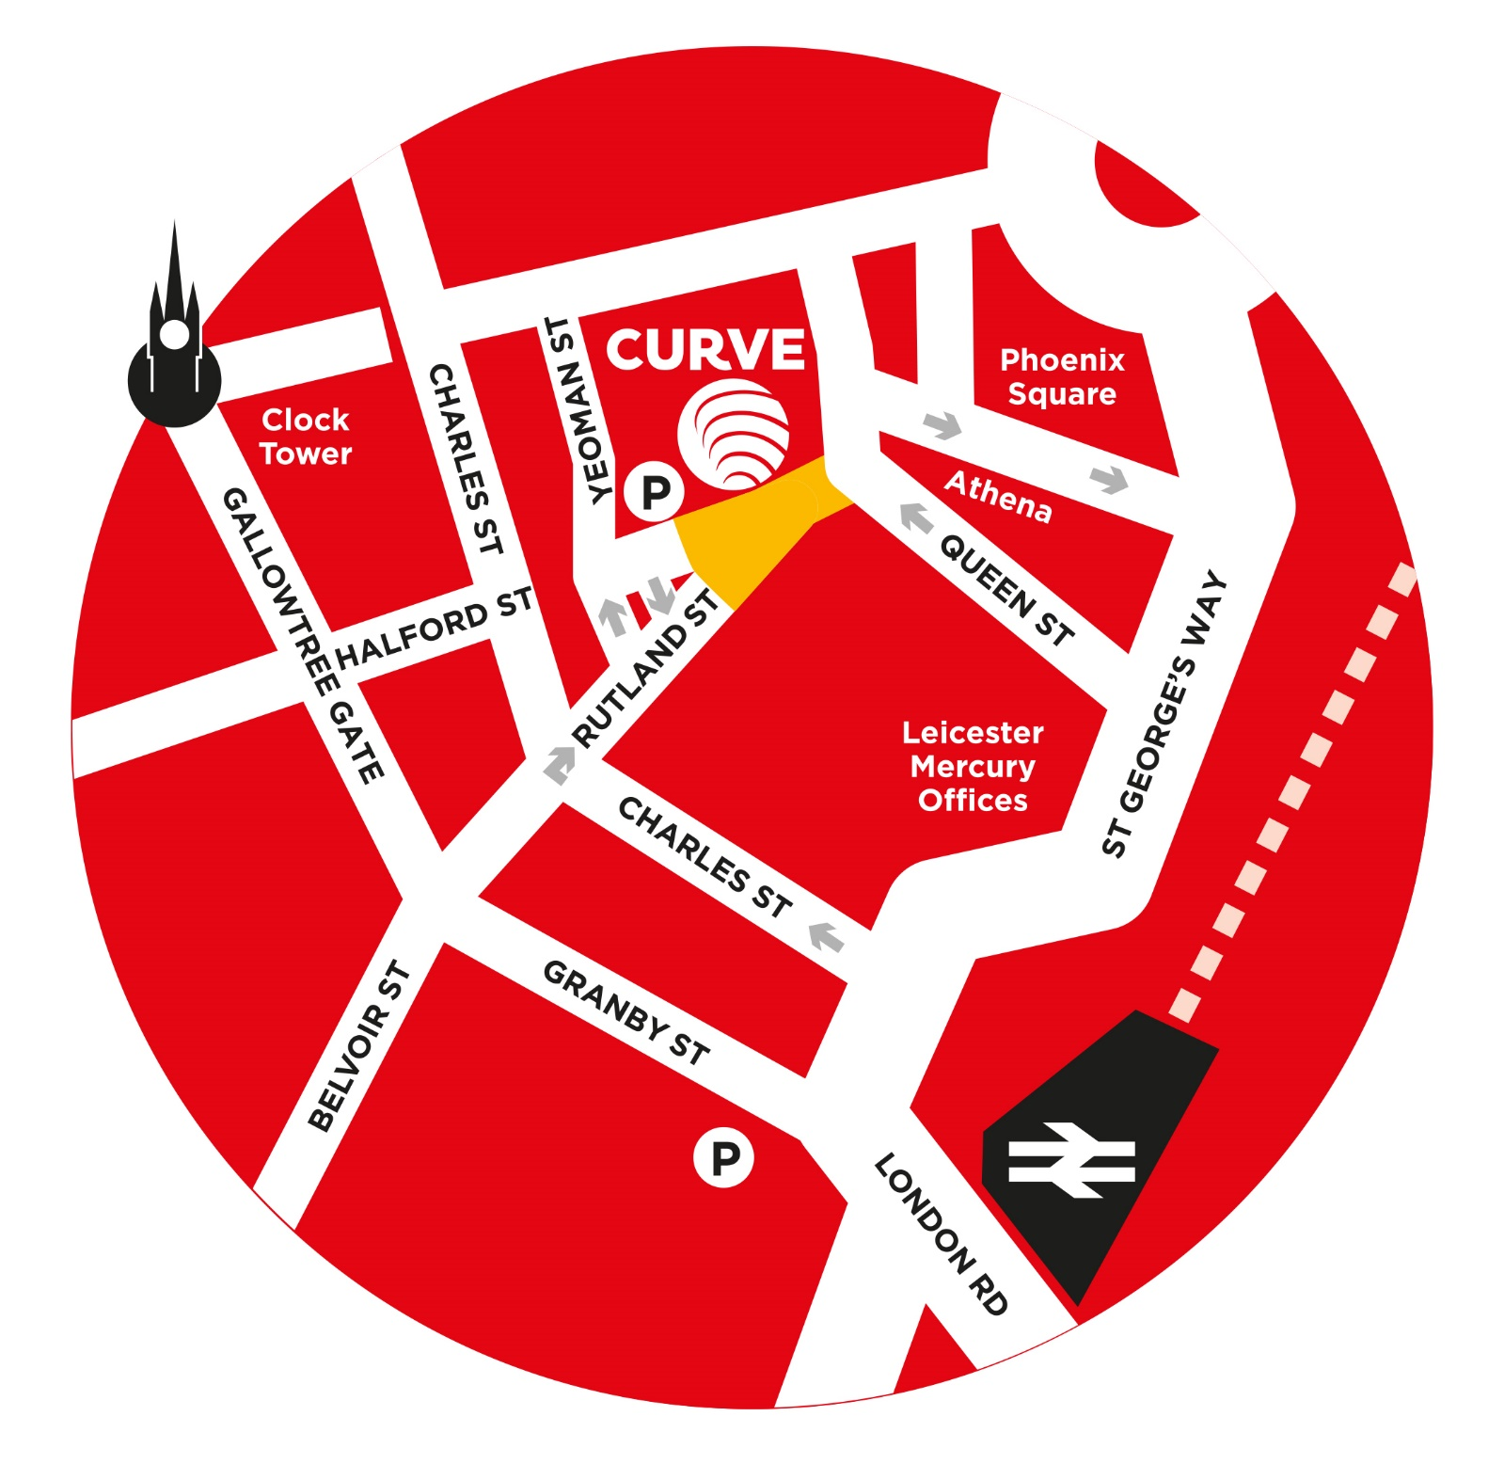

Getting here by Car
The nearest car park to Curve is the NCP Rutland Centre Multi-storey Car Park, next door to the theatre. The address for the car park is 56 Halford Street, Leicester, LE1 1TQ, and it has seven access spaces.
Visitors to Curve can park at NCP Rutland Centre Multi-storey Car Park for a reduced rate of £5.50 – please validate your car park ticket at our Box Office during your visit.
Other nearby car parks include Queen Street Car Park (LE1 1QD), NCP Lee Circle (LE1 3RE, four access spaces) and Highcross John Lewis Car Park (LE1 4QJ, 70 access spaces).
There is also a drop-off point outside our theatre.

Getting here by Bus
All Leicestershire bus services have stops within a three to 10-minute walk of Curve. Services that stop on or near Humberstone Gate or at Haymarket Bus Station are the closest.
Due to the temporary closure of St Margaret’s Bus Station, regional bus services are currently terminating at alternative stops around the city. For more information, please see www.leicester.gov.uk/media/5k3bqvgd/smbs-replacement-stops-map.pdf, or contact service providers directly for the latest information on your service.
For more information on your nearest bus stop, visit the Leicester City Council website at www.leicester.gov.uk/transport-and-streets/travelling-by-bus/, or call Traveline on 0871 200 2233.
Getting here by Train
Leicester Train Station is less than a 10-minute walk away via Charles Street. For the latest service information, please visit www.nationalrail.co.uk.

About the Show

What the Ladybird Heard is based on the book What the Ladybird Heard by Julia Donaldson and Lydia Monks. You might have read this with your family at home!

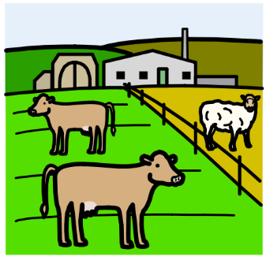
If you are new to the book, it tells the story of a farm where there a lots of animals and a farmer who has a fine prize cow. There are two robbers - Hefty Hugh and Lanky Len – who want to steal the cow, but the Ladybird hears their plan, so her and the animals stop them with a cunning plan of their own! In the stage version, there is a farmer and farmhands who work on the farm where the Ladybird lives. They act out the story for us using songs. You can find out more about the story on pages 10 – 12.

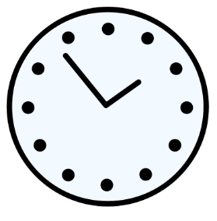
The running time for What the Ladybird Heard is 55 minutes with no interval.
The performance is recommended for children aged 3+ and their families.
Things to Look Out For

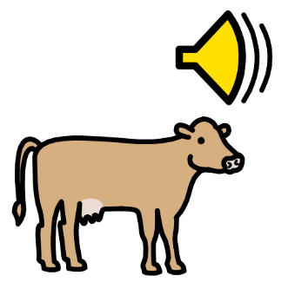
What the Ladybird Heard uses lots of puppets to create the different animals. You will see these throughout the play as most of the characters in the show are either people or animals.
The actors will move and occasionally make sounds like animals.
Widgit Symbols © Widgit Software 2002-2021, www.widgit.com
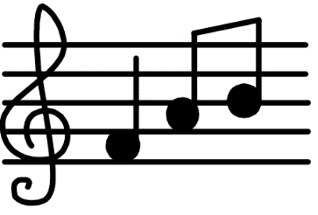
There is a mixture of live and recorded music during the show, as well as different instruments on stage at different times.

The show is quite noisy, and even though the sound level for this relaxed performance will be reduced, you should expect some songs with audience and cast interaction. There will also be some bangs from the noise of Hefty Hugh and Lanky Len’s van.
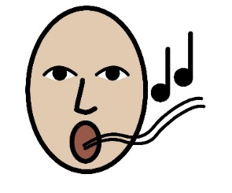
There is a lot of music in the show and the audience are welcome to sing along. Other people in the audience can get quite loud at these bits. You can join in or not – it’s up to you!

There are other moments during the show when the actors will talk directly to the audience. You can reply or not, it’s up to you - no one will be made to feel embarrassed.

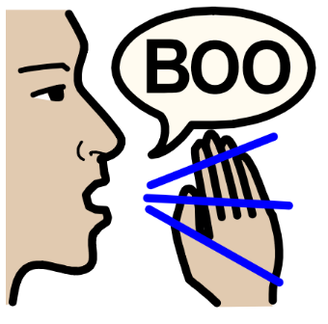
There are some characters that the audience might not like, and some people may ‘boo’ them as they will be seen as bad people. These characters are likely to be Lanky Len and Hefty Hugh who try to steal the prize cow during the show.
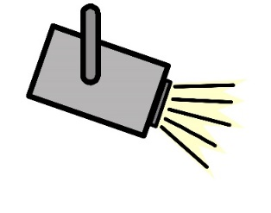
For this performance we will keep the main lights on in the auditorium but there will be different lighting changes during the show and especially during songs.

Widgit Symbols © Widgit Software 2002-2021, www.widgit.com.

The Cast
There are four actors in the show, three male and one female. All of the actors act, sing and play musical instruments during the show.
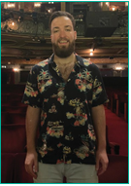
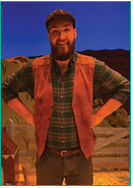
Roddy Lynch – Farmer
This is Roddy. He is an actor.
Roddy plays the Farmer in the show.

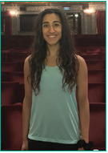
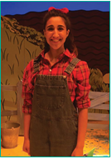
Nikita Johal – Lily/Ladybird
This is Nikita. She is an actor.
Nikita plays Lily who works on the farm in the show. She also represents the Ladybird when she plays her flute.
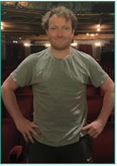
Matthew McPherson – Hefty Hugh
This is Matthew. He is an actor.
Matthew plays a farmhand and Hefty Hugh. A farmhand is someone who works on a farm and helps the farmer.

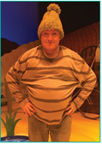
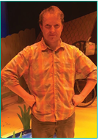
When he is dressed like this, he is playing Hefty Hugh.
When Matthew is dressed like this, he is a farmhand.

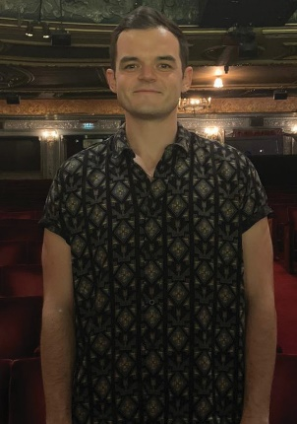
James Mateo-Salt – Lanky Len/Raymond
This is James. James is an actor.
James plays Raymond, who is an usher for the theatre who joins the action on stage. He also plays Lanky Len.
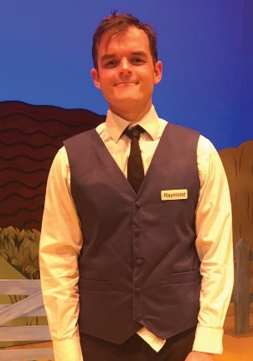
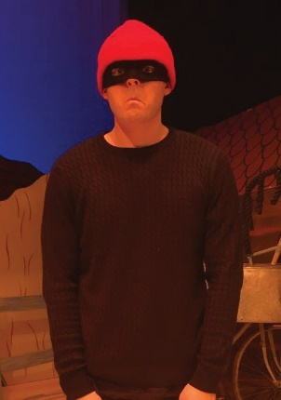
When James is dressed like this, he is playing Lanky Len.
When James is dressed like this, he is playing Raymond.

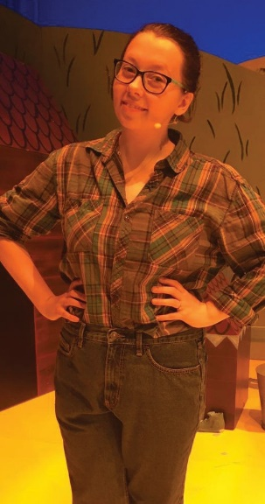
Abigail Middleton – Understudy/ASM
This is Abigail. Abigail is the Understudy, so she will sometimes perform as Lily/Ladybird, Lanky Len or Farmer if someone else can’t.
She is also the ASM, which stands for Assistant Stage Manager. This means she helps set props at the side of the stage for the actors, moves things during the performances (you might catch a glimpse of her at some points in the show!) and helps the actors to their jobs. At the very end of the show, she appears as a policewoman to take away Hefty Hugh and Lanky Len.

What the Ladybird Heard - The Story
Spoiler Alert
Below is a summary of the story which means we tell you what will happen. This might be helpful to know before you come to the theatre, but if you want the story to be a surprise then we suggest you don’t read these pages. Please don’t share these with other people as they might want the surprise too. There are things about the show which have been changed from the books to make it longer and work in a theatre, so you can learn about these bits in the summary too.

What the Ladybird Heard opens with Lily, a farmhand, reading the book version on stage in the farmyard. She lifts her head from the book and begins to call the ladybird with the aid of her flute: ‘Ladybird, Ladybird, where are you?’
What the Ladybird Heard is her favourite story, and she tells everyone that it happened right here on the farm. She asks everyone if they know it.
The cockerel crows and the day on the farm begins. Eddy, another farm hand, joins Lily on stage and the animals start to wake up. We meet the cats and the cow, which are puppets that the actors operate from behind a screen.
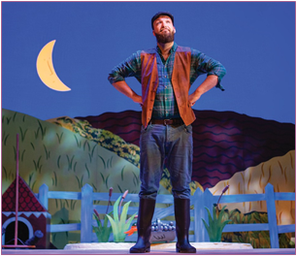
We then we meet Jo the Farmer who says hello to everybody. They are going to tell us the story of What the Ladybird Heard. Lily will be the storyteller and the Ladybird. The Farmer will play himself and Eddy will play Hefty Hugh. Eddy realises they are missing one person though – Lanky Len. They ask everyone to do their best impression of Lanky Len to see if there is anyone in the theatre suitable to play the part. They find Raymond, an usher in the theatre. He is perfect for the part and with some encouragement joins them on stage.
The story begins. The Farmer is returning from the country fair and his cow has won a prize. He makes sure to shut the gate so that no thieves get in to steal his fine prize cow!
Raymond asks where the rest of the farmyard animals are. Eddy suggests they make them out of other items they find around the farmyard. They will ask everyone to remind them which animals are in the story and then make the animals one by one.
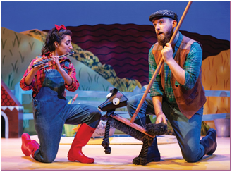
Once they have all the animals, the actors will sing a song about them (♫ Once Upon a Farm), and you can join in if you want to! They will call out for the Ladybird and she appears briefly on stage in the form of a lit projection that shows in different parts of the set. Finally, she settles on a tree branch. Eddy and Raymond leave the stage to get into their Hefty Hugh and Lanky Len costumes and Lily and the Farmer sing ♫ Once Upon a Farm once more before leaving the stage.
The stage gets darker and Hefty Hugh and Lanky Len drive onto the stage in their getaway van. They tell us about their life of crime and their plan to steal the Farmer’s fine prize cow:-
Open the gate at dead of night.
Pass the horse and then turn right.
Round the horse and then turn right.
Round the duck pond, past the hog (be careful not to wake the dog).
Left past the sheep, then straight ahead
And in through the door of the prize cow’s shed.
They run through the plan a few times and leave the stage, telling us they will return the next night to steal the cow.
It’s now morning again and the cockerel crows. It’s the start of a new day and feeding time for the animals. The Farmer, Lily and Eddy sing a song about what the animals all eat and the day on the farm, and there’s exciting news – a new foal has been born.
The day is over and the Farmer says good night to his farm and animals. During the night, Hefty Hugh and Lanky Len arrive at the farm to steal the cow but they do not realise the little Ladybird is listening to them. Lanky Len wants to run through the plan once more but the sun rises and they are scared off by the cockerel’s crow, cock-a-doodle-doo!
Lily speaks for the Ladybird to tell the farmyard animals what she overheard, that Lanky Len and Hefty Hugh are planning to steal the cow by creeping into the farm at the dead of night.
But the Ladybird has a good idea, and she whispers into each animal’s ear. If each animal makes a different sound they will all confuse the robbers, so the goose would say NEIGH not HISS, the dog would QUACK not WOOF.
At this point, the Ladybird is represented by a small red light and the theatre might go a little bit darker so that you can see the Ladybird as she dances and flies around all the animals.
Hefty Hugh and Lanky Len arrive at the farm ready to steal the cow. It’s dark at night so they have to tiptoe carefully round the pond.
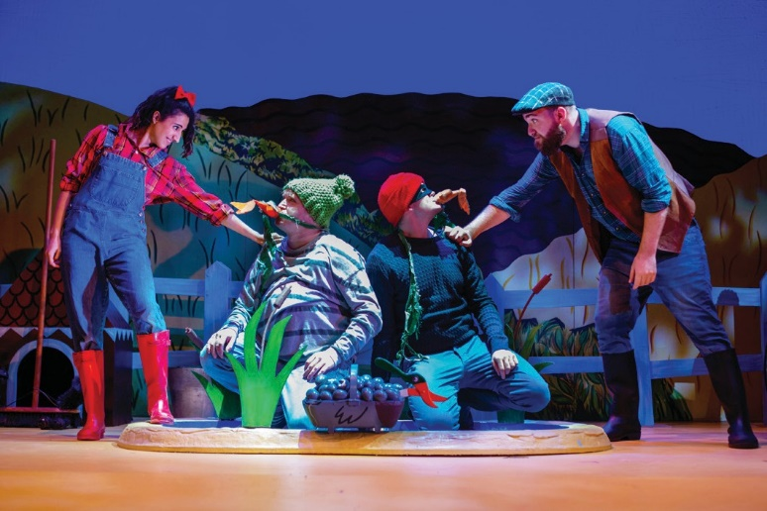
Each animal makes the wrong noise and the robbers lose their way round the farm and fall in the pond. The splosh from the pond wakes the Farmer who calls the Police, and the robbers are taken away.
All of the storytellers come back on to stage at the end and sing a song to celebrate that the robbers were caught and the fine prize cow is safe.
The actors will ask you to join in with the singing and the movements, which you can do if you would like to!

Visual Story: Your Visit to Curve
Curve is a large, round building with a glass front, as shown below.
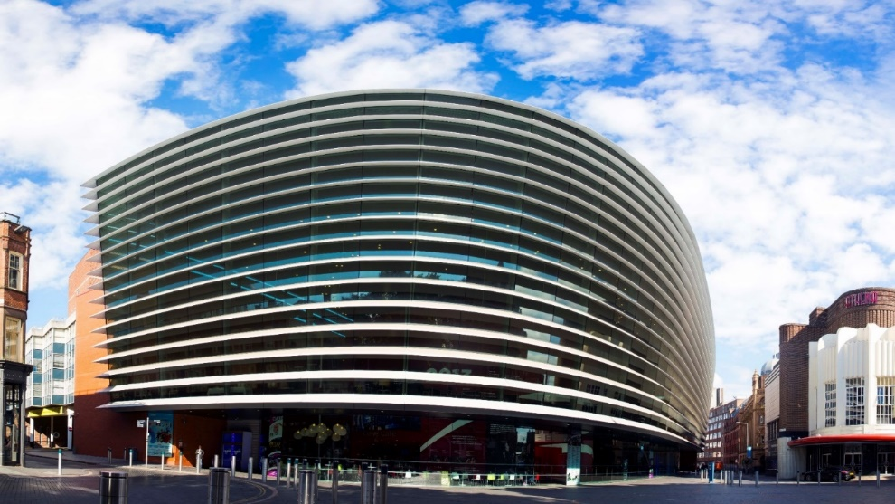
The outside of Curve looks like this:

Halford Street Entrance
what3words: ///wide.wiping.dared
Rutland Street Entrance
what3words: ///driver.other.ideal

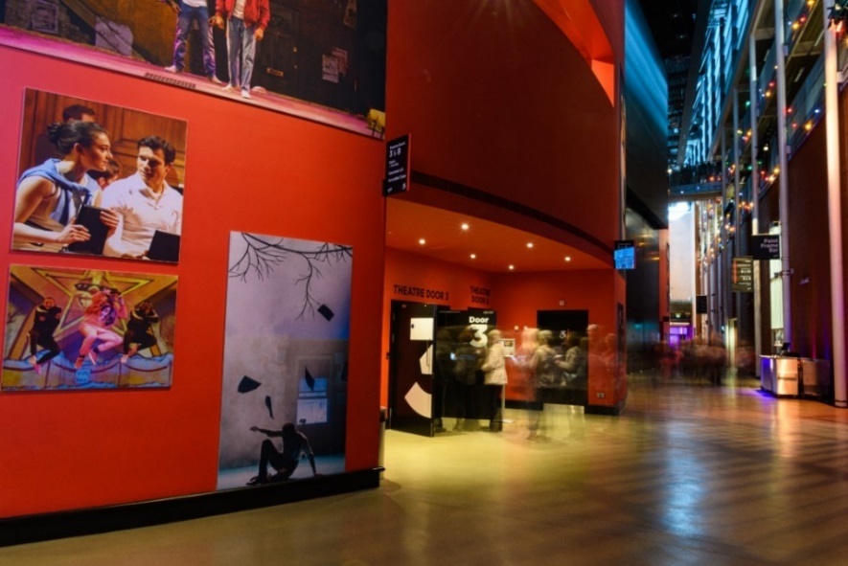
There are two main entrances into the building – one by our Green Room Café (Halford Street), and another by our Box Office (Rutland Street).
Both entrances have a set of glass double doors. Both doors can be opened by pressing the silver button on the wall or rail, but the Rutland Street doors will open outwards automatically as you move towards them.
There is level access into the building from both entrances.
When you enter the building, you will be in the Foyer. Our Foyer is one big circle which wraps around our two performance spaces – the Theatre and the Studio.
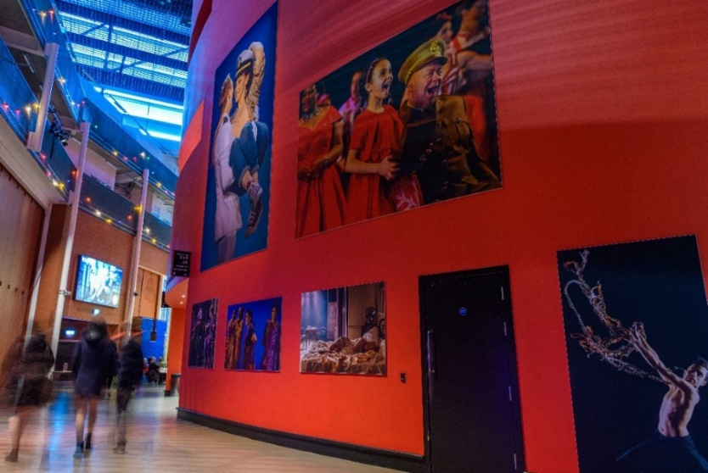
As you make your way around the Foyer, you will notice lots of large pictures on the big red walls. This is our production gallery, and features pictures from previous productions here at Curve.

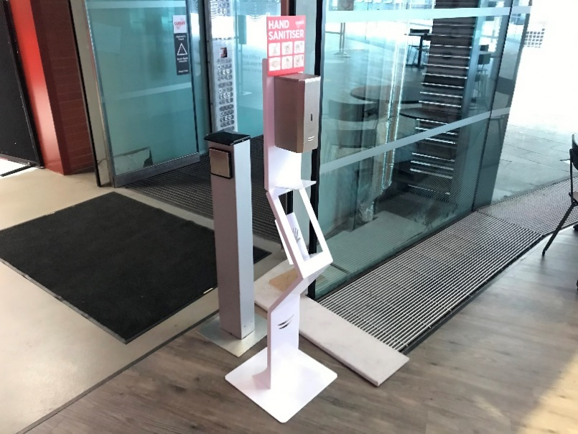 | A number of automatic hand sanitiser points are available around the building. To use these points, simply hold your hand beneath the dispenser.  A number of push dispensers are also available around the building.
Before the show and during the interval, there will be some loud announcements in the Foyer telling you how long it is until the show begins, and other useful information about your visit. These will be at a quieter level during the Relaxed Performance.

It may also be noisy in the Foyer as other audience members will be arriving to see the show. You might like to cover your ears or wear a pair of ear defenders during this time.

Widgit Symbols © Widgit Software 2002-2021, www.widgit.com.
Here is a map of the Ground Floor of our Theatre.
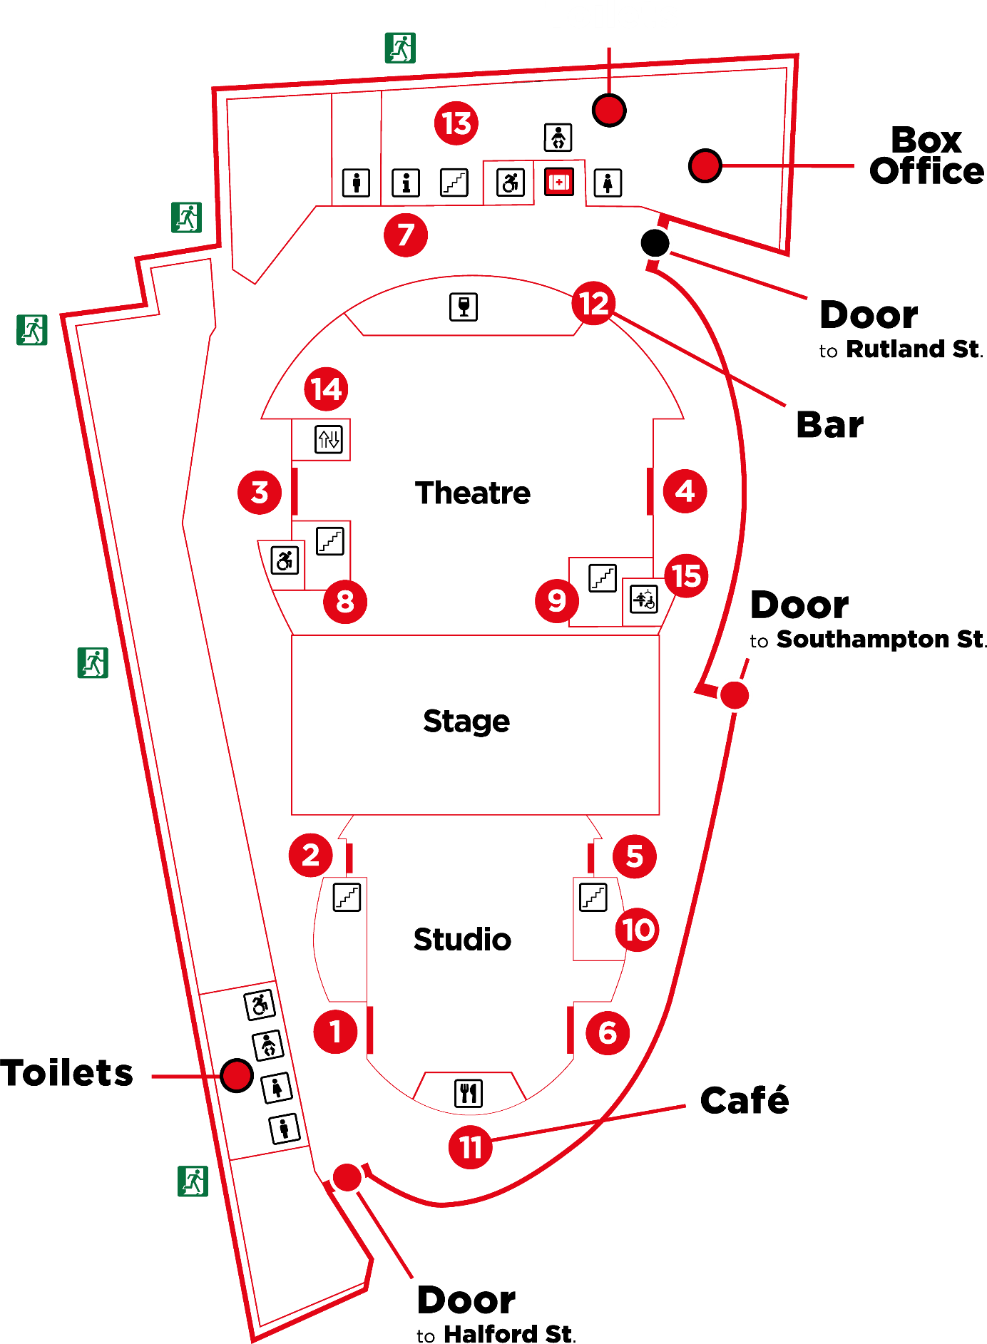

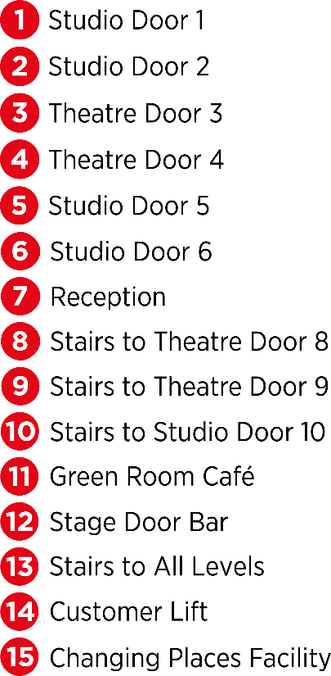

In the Foyer inside the Rutland Street doors, you will find our Box Office.
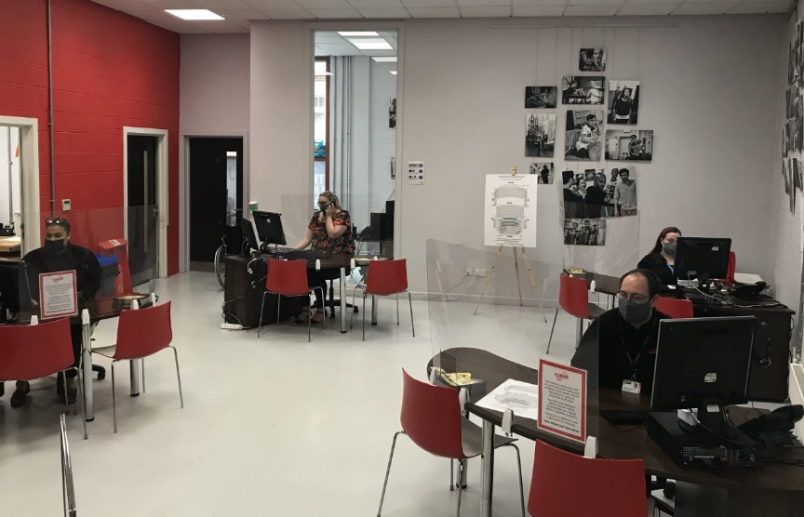
This is where you can collect your tickets for the show or buy tickets if you have not already booked.
Other audience members will also be collecting their tickets, so there might be a small queue.
Car parking tickets for cars parked in the NCP Rutland Centre Multi-storey Car Park next door to Curve can be validated at the Box Office for £5.50.
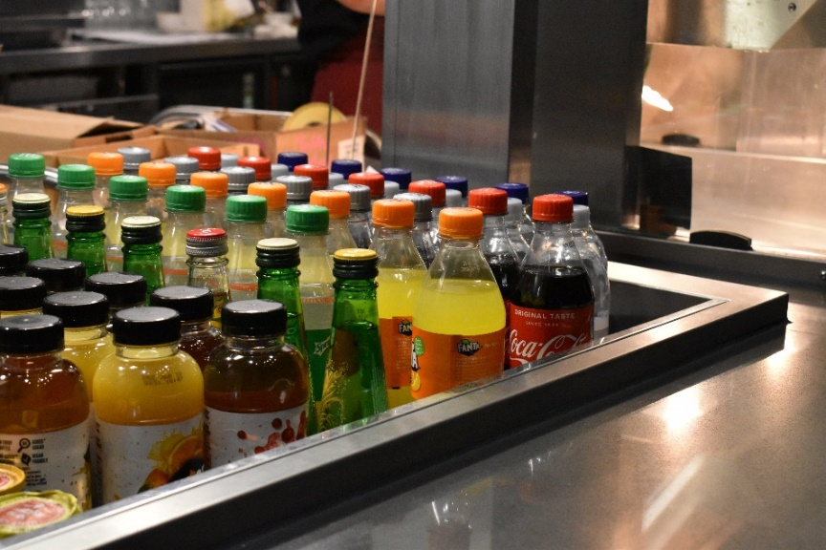
In the Foyer you will also find our Green Room Café.
Here you can buy a drink, snack or ice cream to enjoy before the performance.
There may be a small queue at the Café.

If you need to use the toilet before you take your seats, there are male, female and accessible toilets near the Green Room Café and Box Office.
All hand dryers will be turned off during the Relaxed Performance, and paper towels will be provided.
A R.A.D.A.R key is available at the Green Room Café.
The toilets look like this.

There is also a Changing Places Facility with adult hoist on the Ground Floor next to Theatre Door 4. Please note you will need to bring your own hoist straps to use this facility.

You will be watching What the Ladybird Heard in the Studio. Here is a picture of the seats in the Studio. This is where you will sit to watch the performance.
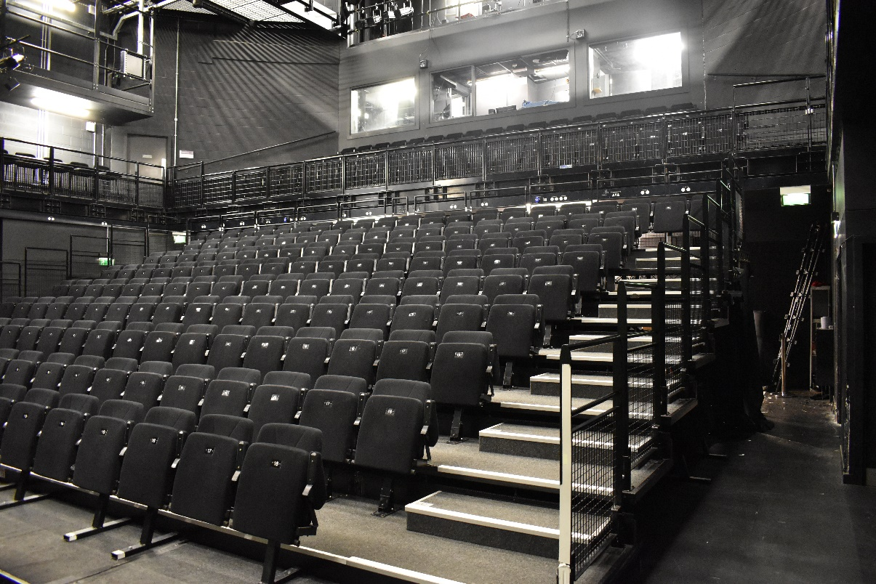

Balcony

Stalls

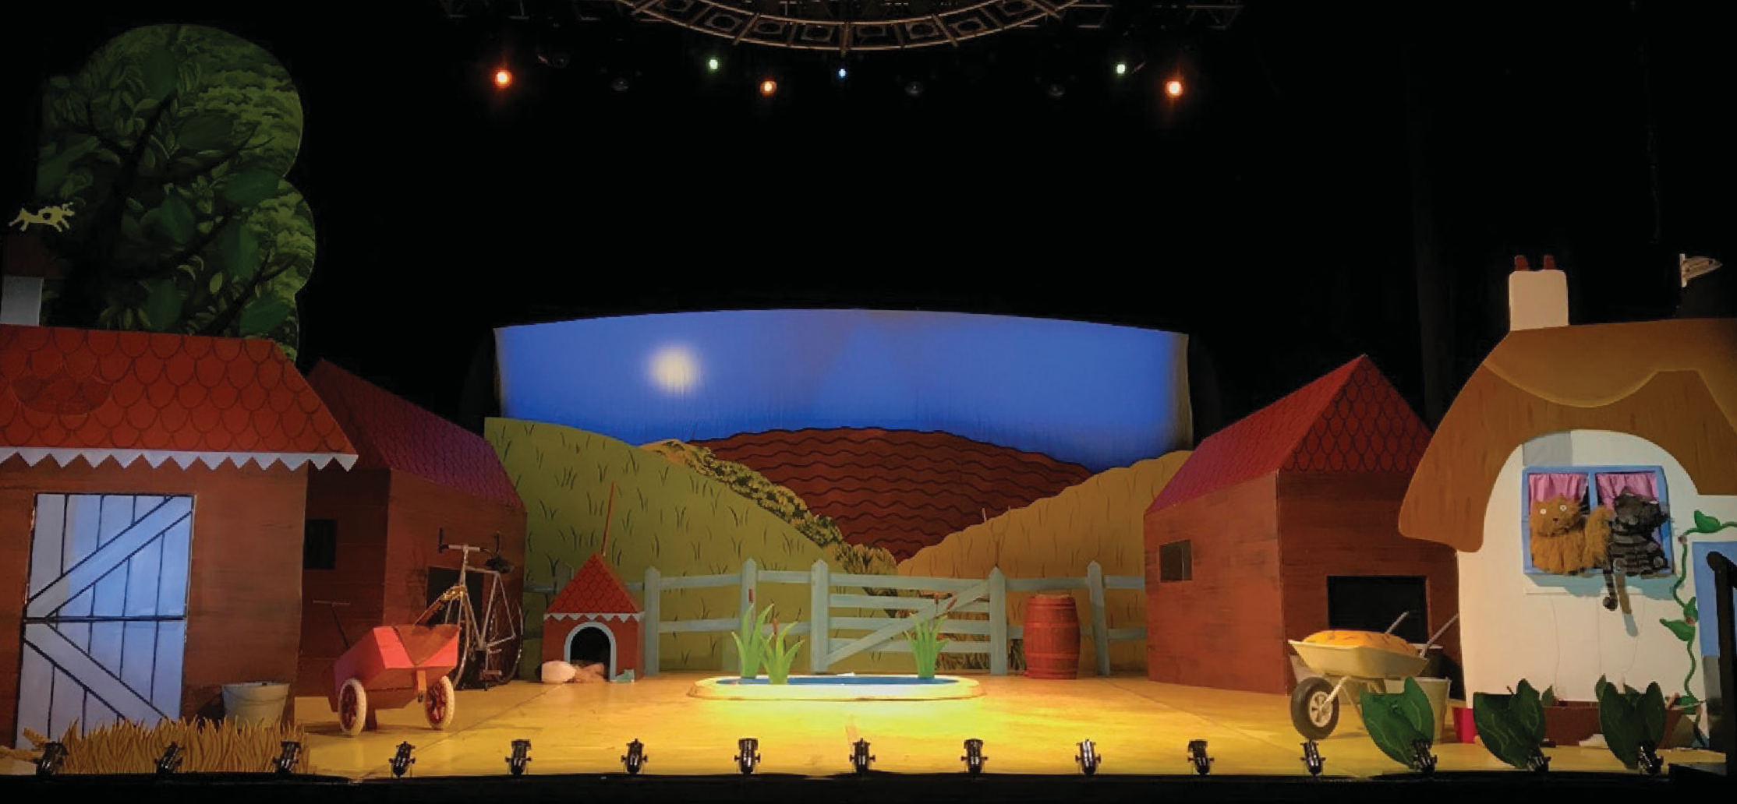
When you enter the Studio, the stage will look like the picture below, with the farmyard set in place. The stage is the area where the actors perform the show, and the set is the name for the scenery, furniture and objects used on the stage during a show.

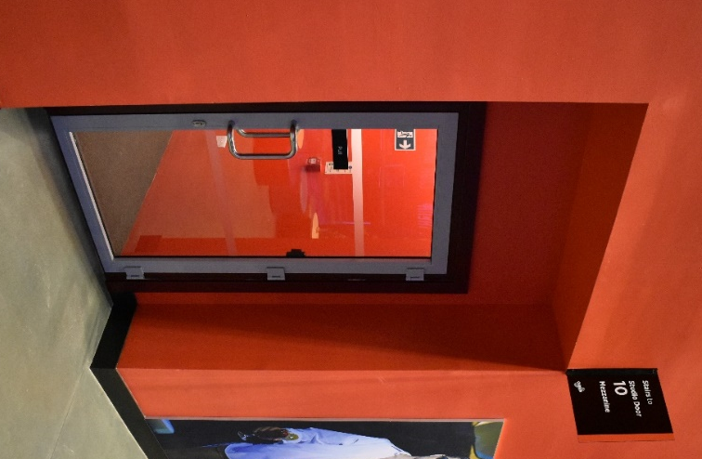
Your ticket will tell you if you are sitting in the Stalls (ground floor, enter through Studio Door 1 or 6) or in the Balcony (upstairs, enter through Studio Door 10).
Your ticket will also tell you what door to enter through and where to sit.

A member of our Visitor Experience Team can help you find the right door and your seat by looking at the letters and numbers on your ticket. They will be wearing black shirts with a colourful Curve logo.
When you enter the Studio, the lights will be on and it may be noisy as the audience will be excited to see the show. You might like to cover your ears or wear your ear defenders to soften the noise, and bring a toy to play with before the performance starts.
You will need to pull the bottom of your seat
down to sit on it.
Booster seats are available if you can’t see the stage comfortably, and a member of our Visitor Experience Team can get one for you.
They will also be happy to help you with anything else you may need to enjoy the performance.

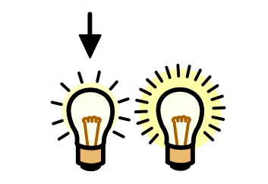
When the show is about to start, the lights in the Studio will be dimmed but it will never go completely dark.
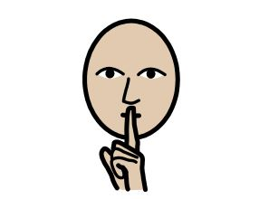
Everyone will try to be as quiet as they can so they can listen to the story and music, but you are welcome to interact with the performance if you would like to!

The doors of the theatre will remain open throughout the performance so you can leave and re-enter the Studio, should you need to use the toilet or take a break from the performance.

If you need a break from the performance, you can visit our quiet space in Rehearsal Room 2 (RR2) on the Mezzanine (Level M).
You will need to take the stairs or the public lift next to Theatre Door 3 to access RR2, and a member of our Visitor Experience Team can help you find it.

When the show has finished, the cast will come back onto the stage and bow. The audience will clap to show the cast they enjoyed the performance. You can also clap if you would like to!
Widgit Symbols © Widgit Software 2002-2021, www.widgit.com.
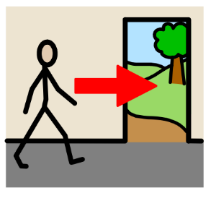
At the end of the show, the lights will get brighter.
Our Visitor Experience Team will let you know when you can exit the Studio - this is to ensure all audience members can leave the theatre safely.

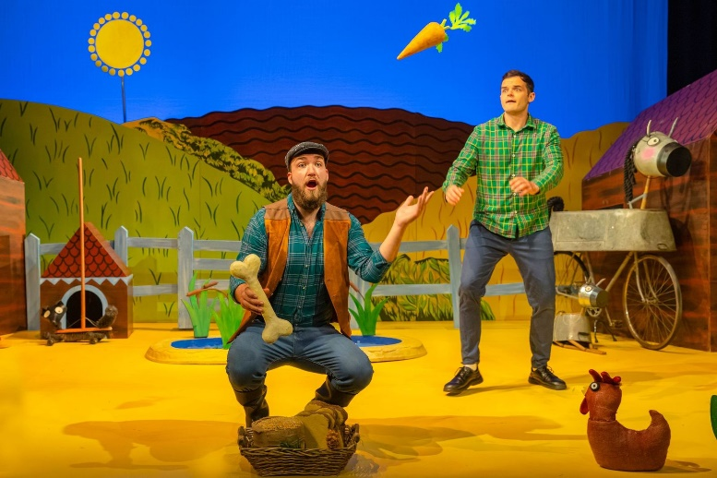
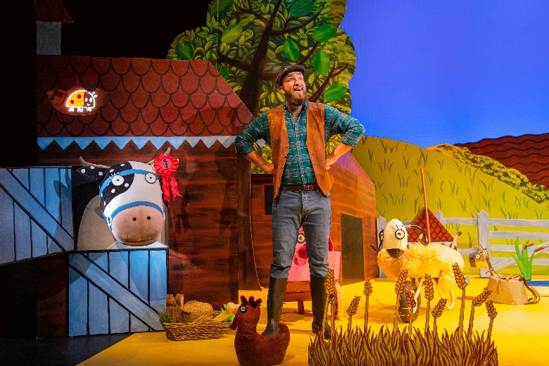
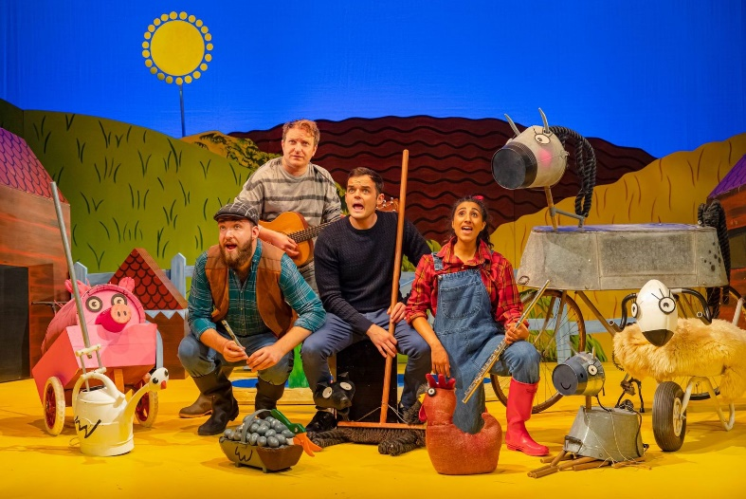
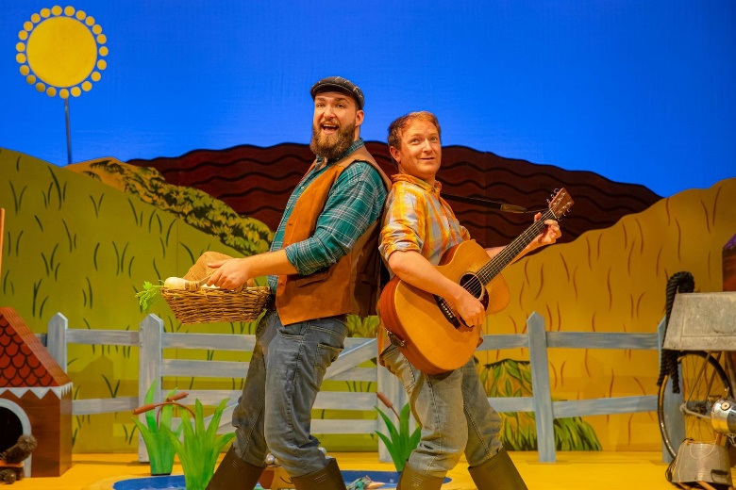
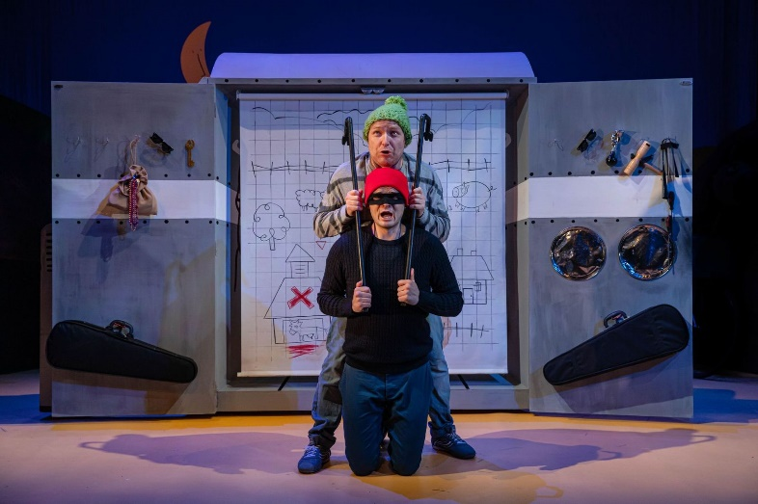
Production Gallery
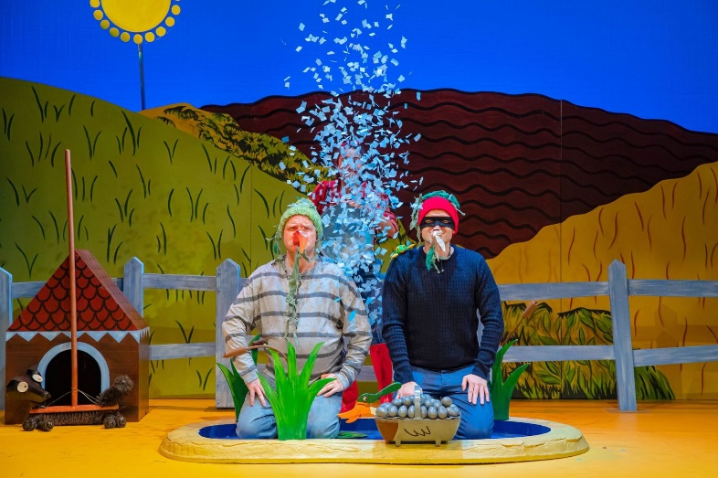
Widgit Symbols © Widgit Software 2002-2021, www.widgit.com

We hope you find this information pack helpful ahead of your visit to Curve. Enjoy the show!
If you have any comments on this information pack, please email us on access@curvetheatre.co.uk.
For more information about Accessibility at Curve, please visit www.curveonline.co.uk, or call our Box Office on 0116 242 3595.
We look forward to welcoming you.

