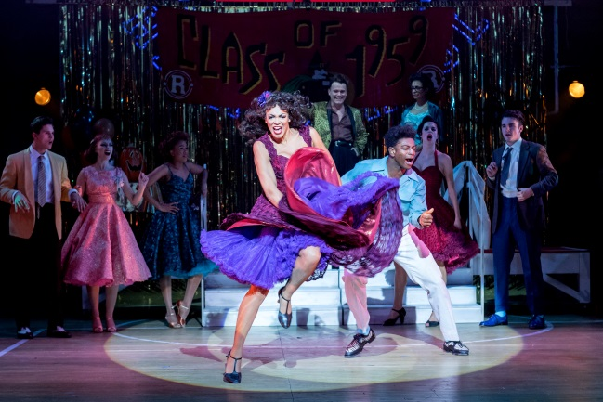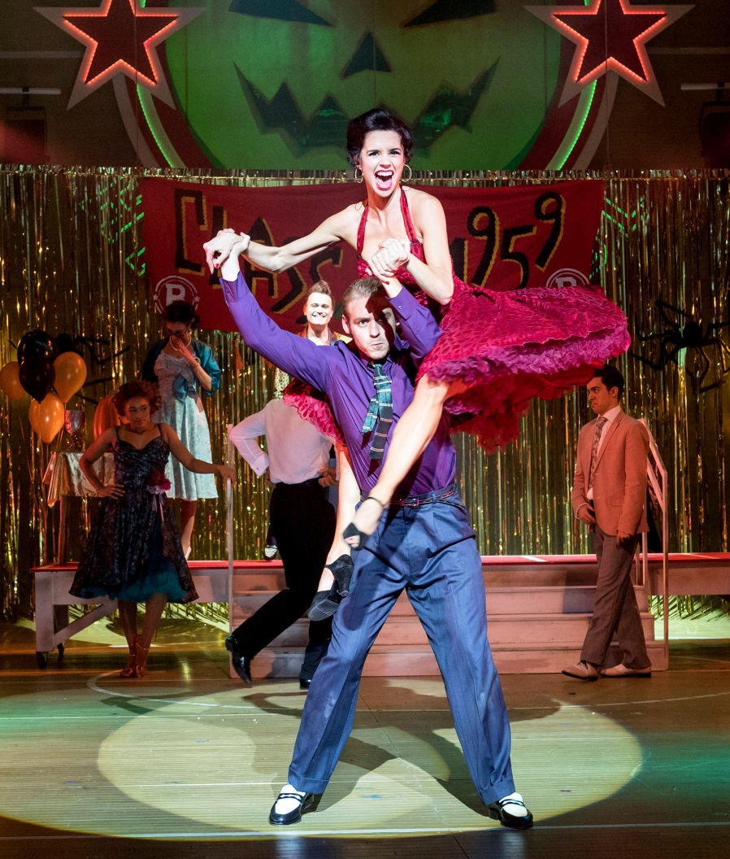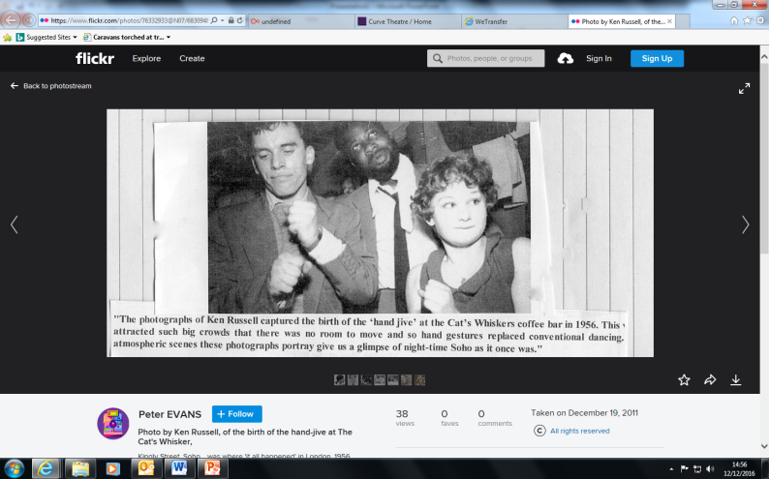

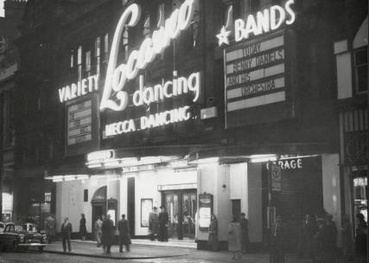

***Dance halls were the tinder of their day.***

***In 1953 they were described as Britain’s second-biggest entertainment industry after Cinema.***

***They became the meeting places for girls and boys who were the teenagers of the 50’s. The Hand jive became a social dance.***

***The hand jive mainly consists of hand gestures – this was because there was no room to dance within the halls.***

***When it became partnered in ‘Grease’ we started to see lifts.***

***The pattern of hand movements that went on during the hand jive were meant to imitate percussion instruments. The dance is so simple that it has often been described as ‘an elaborate version of patty cake’ It’s simplicity was one of the main reasons it became so popular – anyone could do it!***

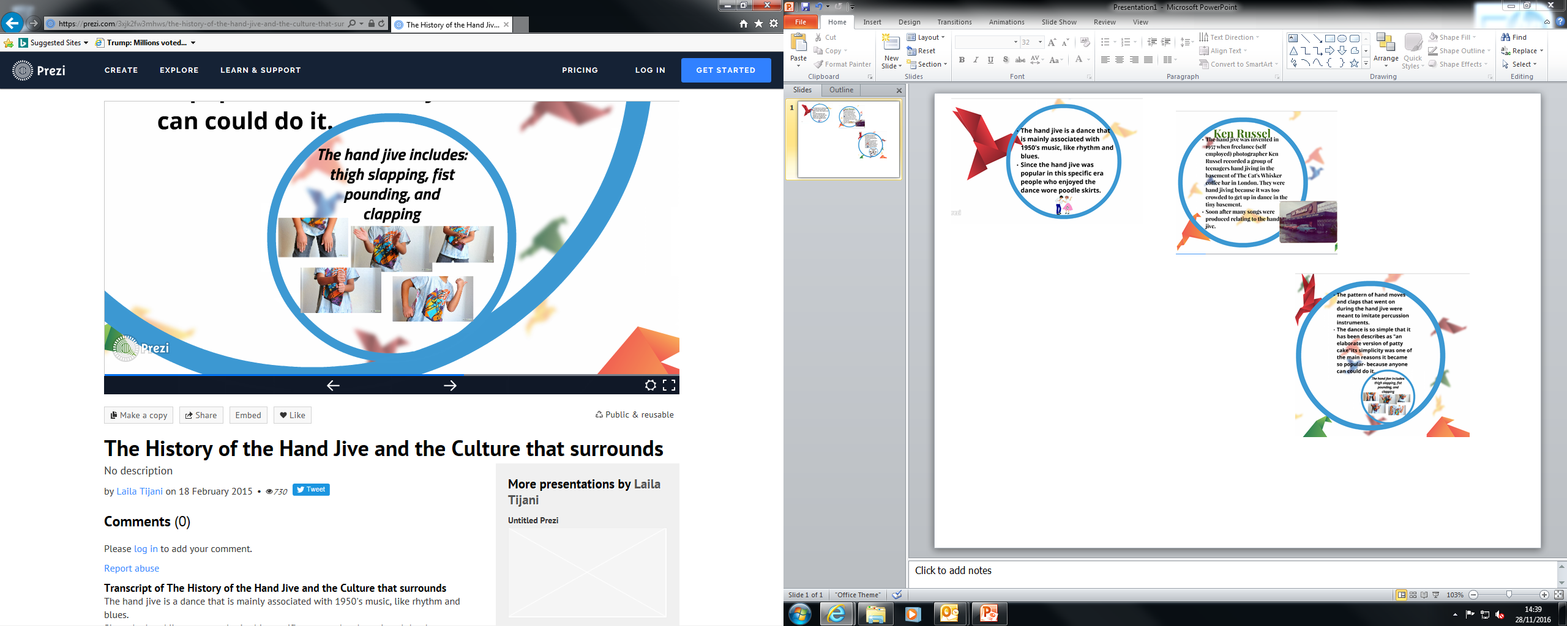

***Girls wore poodle skirts to take part in the dance. This costuming can be seen in Act 2, Scene 1- Dance.***

***How was the skirt used within the dance?***

***Grease & the Hand Jive***

***Most people know the hand jive from the movie ‘Grease’ made in 1971 which was made 14 years after the hand jive was introduced. The song associated with the dance in Grease is “Born to hand Jive”.***

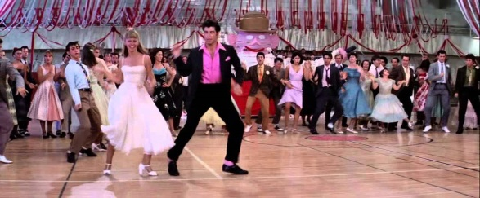

***Ken Russell***

***The hand jive first became known in 1957 when freelance (self-employed) photographer Ken Russell recorded a group of teenager’s hand jiving in the basement of The Cat’s Whisker coffee bar in London.***

**History!**

***The hand jive is a dance that is mainly associated with 1950’s music.***

***Find out different styles of 1950’s music.***

**Hand Jive**